A Study of Structural and Simultaneous Equation Modelling

A Research Project report submitted in partial fulfilment of the Requirement for the Degree of M.Sc. (Statistics)
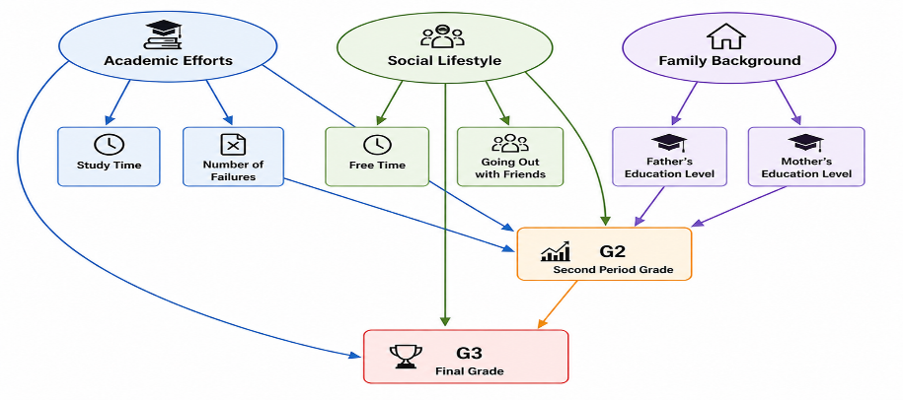
Submitted by M.Sc (Statistics) Students

Mr. Mahajan Ghansham Dnyaneshwar (seat no. 708156)
Ms. More Mohini Sunil (seat no. 708161)
Ms. Patil Aishwarya Paresh (seat no 708165)

Under the guidance of
Prof. K. K. Kamalja


DEPARTMENT OF STATISTICS
SCHOOL OF MATHEMATICAL SCIENCES
KAVAYITRI BAHINABAI CHAUDHARI
NORTH MAHARASHTRA UNIVERSITY JALGAON–425001
(2025-26)

CERTIFICATE

This is to certify that Ms. Aishwarya Paresh Patil, Ms. Mohini Sunil More and Mr. Mahajan Ghansham Dnyaneshwar students of M.Sc. (Statistics) with specialization in Industrial Statistics, at Kavayitri Bahinabai Chaudhari, North Maharashtra University, Jalgaon have successfully completed their project work entitled "study ” as a part of M.Sc. (Statistics) program under my guidance and supervision during the academic year 2025-2026.

Prof. K. K. Kamalja
(Project Guide)
Signature: ..........

Abstract
This study aims to analyze the factors influencing student academic performance and to evaluate predictive approaches using both statistical and machine learning techniques. The dataset includes variables related to academic effort, social lifestyle, and family background affecting students’ final grades.
Initially, exploratory data analysis and correlation analysis were conducted to understand the relationships among variables. The results indicated that the second period grade (G2) has a strong positive association with the final grade (G3). Multiple Linear Regression further confirmed that G2 and G1 are the most significant predictors of G3.
The analysis was extended using simultaneous equation modelling to capture the interdependence among variables. The results showed that G2 acts as an intermediate variable influenced by factors such as study time, failures, and social activities, and in turn strongly affects G3.
Further, SEM was applied to analyze direct and indirect relationships using latent constructs, namely Academic Effort (studytime, failures), Social Lifestyle (goout, freetime), and Family Background (Medu, Fedu). Due to the violation of multivariate normality, Partial Least Squares SEM (PLS-SEM) was used, which confirmed that G2 is the strongest predictor of G3 and acts as a mediating variable.
The predictive capability of the model was evaluated using PLS-SEM, which showed satisfactory performance. In addition, machine learning models including Decision Tree, Random Forest, XGBoost, and Support Vector Regression were applied. The results indicated that Decision Tree and XGBoost achieved strong predictive performance, with Decision Tree performing best for the given dataset. Machine learning models also identified G2 as the most important predictor.
The study concludes that G2 plays a central role in determining final academic outcomes. The combination of statistical modelling and machine learning provides a comprehensive framework that integrates both interpretation and prediction.

Acknowledgement
We would like to express our sincere gratitude to Prof. K. K. Kamalaja, Head of the Department of Statistics, Kavayitri Bahinabai Chaudhari North Maharashtra University, Jalgaon, for her constant support, valuable guidance, and encouragement throughout this project. Her insightful suggestions and positive attitude have greatly contributed to the successful completion of our work.
We are deeply thankful to our project guide, Prof. K. K. Kamalaja, for her continuous guidance, motivation, and constructive feedback during the entire course of this project. Under her supervision, we have gained significant knowledge and practical understanding, which has helped us complete this work effectively.
We would also like to express our sincere thanks to Prof. R. L. Shinde, Dr. M. C. Patil and Dr. R. D. Koshti for their valuable suggestions and guidance during the project. Their expertise and support have enhanced the quality of our work.
We are grateful to our friends and the non-teaching staff of the Department of Statistics for their support and for providing the necessary facilities required for completing this project.

Place: Jalgaon
Date: 07-05-2026

Miss. Patil Aishwarya Paresh (708165)
Miss. More Mohini Sunil (708161)
Mr. Mahajan Ghansham Dnyaneshwar (708156)

INDEX

Sr. No. | Title | Page No.
1 | Introduction
2 | Structural Equation Modelling  2.1 Background  2.2 What is SEM?  2.3 Principles of Structural Equation Modelling  2.4 Statistics and fit indices in SEM  2.5 Types of SEM  2.6 Advantages of SEM  2.7 Limitations of SEM  2.8 Example  2.9 Research History Table
3 | Simultaneous Equation Modelling  3.1 Introduction  3.2 Need of Simultaneous Equation Modelling (SyEM)  3.3 Model of SyEM  3.4 Advantages of SyEM  3.5 Limitations of SyEM  3.6 Example  3.7 Research History Table
4 | Methodology  4.1 R Packages  4.2 Concepts used for data analysis
5 | Modelling Student performance using SEM, SyEM and ML tools  5.1 About student academic performance Data  5.2 Exploratory Dat Analysis  5.3 Modelling with Classical MLR  5.4 Checking Assumption for regression  5.5 Modelling with Simultaneous Equation Modelling  5.6 Modelling with Structural Equation Modeling  5.7 Performance of SEM and SyEM  5.8 PLS-SEM Prediction Analysis  5.9 Modelling with Machine Learning tools
6 | Conclusion
 | References

Chapter 1. INTRODUCTION

Introduction

Student academic performance is an important indicator of educational success and is influenced by multiple factors, including academic effort, social behavior, and family background. Understanding these factors is essential for improving student outcomes and developing effective educational strategies.
In educational data analysis, traditional statistical methods such as correlation analysis and Multiple Linear Regression are widely used to examine relationships among variables and identify significant predictors of student performance. These methods provide useful insights into how individual variables, such as study time or prior grades, are associated with final academic outcomes. However, these approaches mainly focus on direct relationships and may not fully capture the complex interdependence among variables.
In many real-world situations, variables are interrelated and may influence each other simultaneously. For example, the second period grade (G2) is not only influenced by factors such as study time, failures, and social activities but also acts as a predictor of the final grade (G3). To capture such relationships, simultaneous equation modelling is used. This approach allows the analysis of systems of equations where variables can act both as dependent and independent variables, thereby providing a better understanding of intermediate relationships.
Further, SEM extends this framework by allowing the analysis of both direct and indirect effects among variables. SEM also enables the inclusion of latent constructs, which represent unobserved concepts measured through observed variables. In this study, latent variables such as Academic Effort (measured by studytime and failures), Social Lifestyle (measured by goout and freetime), and Family Background (measured by Medu and Fedu) are considered. These constructs help in understanding how different aspects of a student’s environment and behavior influence academic performance.
However, traditional SEM approaches such as Covariance-Based SEM (CB-SEM) require strict assumptions, including multivariate normality. When these assumptions are not satisfied, the results may not be reliable. In such cases, Partial Least Squares SEM (PLS-SEM) is preferred, as it is more flexible and can handle complex models with fewer assumptions. In addition to explaining relationships, PLS-SEM is also useful for evaluating the predictive capability of the model.
In recent years, machine learning techniques have gained importance in the field of data analysis due to their ability to model complex patterns and improve prediction accuracy. Unlike traditional statistical methods, machine learning focuses primarily on prediction rather than interpretation. Models such as Decision Tree, Random Forest, XGBoost, and Support Vector Regression are widely used for predictive analysis and can handle non-linear relationships effectively.
This study integrates statistical methods, simultaneous equation modelling, Structural Equation Modelling, and machine learning techniques to provide a comprehensive analysis of student academic performance. The aim is not only to identify key factors influencing performance but also to evaluate predictive accuracy using different approaches. By combining interpretation and prediction, this study provides a more complete understanding of student performance and its determinants.

Objectives of the Study

The main objectives of this study are:
- To analyze the factors affecting student academic performance
- To examine the relationships among academic, social, and family-related variables
- To identify significant predictors of the final grade (G3)
- To apply simultaneous equation modelling to study interdependent relationships among variables.
- To apply SEM to analyze direct and indirect effects
- To evaluate predictive performance using PLS-SEM
- To apply machine learning models for improving prediction accuracy
- To compare the predictive performance of statistical and machine learning approaches

1.3 Scope of the Study

This study focuses on analyzing student performance data using a combination of statistical and machine learning techniques. The analysis includes variables related to academic effort, social lifestyle, and family background.
The study aims to understand the relationships among variables, identify key predictors of student performance, and evaluate predictive accuracy using different modelling approaches. The findings of the study can be useful for understanding student behavior and improving academic outcomes.

Chapter 2 STRUCTURAL EQUATION MODELLING

2.1 Background

Traditional statistical methods, also known as first-generation multivariate techniques, such as multiple regression, logistic regression, and analysis of variance, have been widely used to examine relationships between variables across various research fields (Haenlein & Kaplan, 2004). These methods have played an important role in generating insights in social sciences, health studies, and economic research, thereby improving the understanding of real-world phenomena. But there are some limitation that are
Limitation: Simple Model Structure
Traditional techniques are based on simple model structures involving one dependent variable and one or more independent variables. As a result, they cannot analyze complex causal chains or interconnected networks of multiple relationships simultaneously (Sarstedt et al., 2020).

Limitation: only observable variable
These methods are restricted to directly observable variables such as age, income, and sales. Abstract concepts, known as latent variables (e.g., attitudes, perceptions, satisfaction), cannot be included directly without prior validation using techniques like Confirmatory Factor Analysis (CFA) (Bagozzi & Philipps, 1982).

Limitation: Assumption of No Measurement Error
Traditional methods assume that all variables are measured without error. In practice, data collection through surveys, observations, and instruments often introduces measurement errors, which can affect the reliability of results. Due to these limitations, researchers sought more advanced analytical approaches capable of handling complex models and imperfect measurements.
This led to the development and adoption of second-generation multivariate techniques, particularly SEM.

2.2 What is Structural Equation Modelling (SEM)?

Structural Equation Modelling (SEM) can be seen as an advanced form of multiple regression. While multiple regression studies the effect of many independent variables on one dependent variable, SEM can study many dependent and independent variables at the same time. They generalize multiple regression in three main ways: there is usually more than one equation, a response variable in one equation can be an explanatory variable in another, and structural equation models can include latent variables.
Multiple equations
Structural equation models are usually based upon more than one regression-like equation. Having more than one equation is not really unique; multivariate regression already does that. But you will see that structural equation models are more flexible than the usual multivariate linear model.

Variables can be both explanatory and response:
- Explanatory variable = a variable that explains or affects another variable (cause)
- Response variable = a variable that is affected by another variable (effect)
In SEM, one variable can be an effect in one equation, and A cause in another equation

Latent variables
Structural equation models may include random variables that cannot be directly observed, and also are not error terms.
Example 1: Student Performance
- Explanatory Variable → Hours studied
- Response Variable → Exam marks
- Latent Variable → Intelligence / motivation (not directly measurable)
That is when study hours increase, exam marks improve, but intelligence or motivation also affects the result.
Example 2: Ice Cream Sales
- Explanatory Variable → Temperature (how hot the day is)
- Response Variable → Ice cream sales
- Latent Variable → People’s mood or preference (you can’t measure it exactly, but it affects buying)
That is when temperature increases, ice cream sales increase, but people’s mood also influences how much they buy.

- General Structural Model
The general form of the structural model in SEM can be written as:
$\underline{η} = B \underline{η} + Γ\underline{ξ} + \underline{ζ}$
Here
$\underline{η}$ (eta) represents endogenous latent variables. These variables are explained by other variables in the model.
$\underline{ξ}$ (xi) represents exogenous latent variables. These variables act as independent variables and are not explained by other constructs in the model.
B represents the matrix of relationships among endogenous variables. It shows how one endogenous variable influences another endogenous variable.
Γ (gamma) represents the matrix that shows the influence of exogenous variables on endogenous variables.
$\underline{ζ }$(zeta) represents structural error terms. These error terms capture the unexplained variation in the endogenous variables.

2.3 Principles of Structural Equation Modelling

There are so many principles of structural equation modelling some of them are discuss below.

1. Path Models with Latent Variables
A path model is a diagram that shows the hypothesized relationships among variables. These models include latent variables (constructs), which are not directly measurable and are shown as circles or ovals, and indicators (manifest variables), which are directly measured and shown as rectangles (Hair et al., 2011; Hair et al., 2020). A PLS path model consists of two main components: the structural model (inner model), which represents the relationships among latent variables, and the measurement models (outer models), which show how each latent variable is measured using its indicators. Measurement models can be specified for exogenous latent variables, which explain other constructs, and endogenous latent variables, which are explained within the model. Relationships in PLS-SEM are represented by single-headed arrows, indicating predictive (and potentially causal) directions. The model also includes error terms, which capture unexplained variance in indicators and endogenous constructs. By combining measurement and structural relationships in one framework, SEM allows researchers to analyse complex theoretical models while accounting for measurement error.

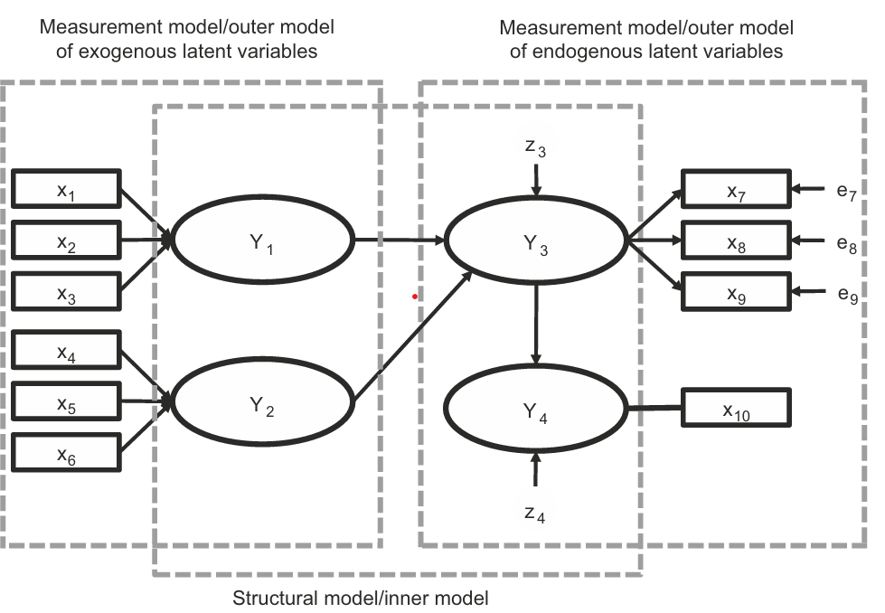
Fig 2.1 A simple path model Source: (Hair et al., 2022, Chap. 1)
Figure 2.1 shows a PLS-SEM path model that includes latent variables, measurement models, structural relationships, and error terms. $Y_{1}$ and $Y₂$ are exogenous latent variables because they explain other constructs but are not explained by any variable in the model, so they are placed on the left side and represented as ovals. $Y₃$ and $Y₄$ are endogenous latent variables because their values are explained by other constructs in the model, so they are shown on the right side of the diagram. The measurement (outer) model explains how latent variables are measured using indicators.
$Y₁$ is measured by indicators $x₁, x₂,$ and $x₃$, which are formative indicators, meaning the direction of the relationship goes from indicators to the construct and no error terms are specified. $Y₂$is measured by indicators $x₄, x₅, and x₆$, which are also formative indicators, so the direction is from indicators to the construct and no measurement error terms are included.
$Y₃$is measured by indicators $x₇, x₈,$ and x₉ using a reflective measurement model, where the direction of the relationship goes from the construct to the indicators and error terms $e₇, e₈,$ and
$e_{9}$ represent unexplained variance. $Y₄$ is a single-item construct measured by $x₁₀,$ and since the construct and the indicator are considered equivalent, no measurement error term is included. The structural (inner) model shows predictive relationships among the constructs with paths from $Y_{1}$ to $Y₃$, $Y₂ to Y₃, and Y₃ to Y₄,$ represented by single-headed arrows.
The model also includes structural error terms $z₃$ and $z₄$, which represent unexplained variance in the endogenous variables $Y₃$ and $Y₄$, while $Y₁$ and $Y₂$ do not have error terms because they are not explained by other constructs.

Testing Theoretical Relationships

Path models are developed based on theory and are used to test relationships between different concepts (constructs). A theory is a group of related hypotheses developed using the scientific method to explain and predict outcomes. A hypothesis is a single statement or assumption that can be tested using data. Two types of theory are required to build a path model measurement theory and structural theory.
Measurement theory explains which indicators (questions or observed variables) are used to measure a particular construct and how well they represent it. Structural theory explains how different constructs are related to each other in the model.
In PLS-SEM, theory testing is done in two steps (Hair, Black, Babin, & Anderson, 2019). In the first step, the measurement model is tested to check whether the indicators are reliable and valid. In the second step, the structural model is tested to examine the relationships between constructs.
This step-by-step process is important because relationships between constructs cannot be tested properly if the measurements are not reliable or valid.

3. Measurement Theory

Measurement theory explains how latent variables (constructs) are measured using indicators. Latent variables cannot be observed directly, so they are measured using observed variables called indicators.
There are two main types of measurement models reflective measurement and formative measurement.
Figure 2.1 constructs $Y₁$ and $Y₂$ use a formative measurement model. In the formative model, arrows go from indicators to the construct, showing that the indicators help form or predict the construct.
For example, indicators $x₁$ to $x₃$ measure $Y₁$ and indicators x₄ to x₆ measure $Y₂.Y₃$ is measured using a reflective measurement mode. In the reflective model, arrows go from the construct to the indicators, meaning the construct causes the indicators to change together. Reflective indicators have error terms, which represent unexplained variation in the indicators.
Formative indicators usually do not include error terms because they are assumed to be error-free (Diamantopoulos, 2006).
$Y₄$ is measured using a single indicator, not multiple indicators. Therefore, the relationship between $Y₄$ and its indicator is undirected.
Choosing whether to use reflective or formative measurement and single or multiple indicators is an important step when developing path models.
Measurement Model for Endogenous Variables
The measurement model for endogenous variables can be written as:
$\underline{y} = Λ_{y}\underline{η} + \underline{ε}$
In this equation, $\underline{y}$ represents the vector of observed indicators for endogenous latent variables.
$Λ_{y}$ (represents the factor loading matrix that shows the relationship between endogenous latent variables and their indicators.
$\underline{η}$ (eta) represents the vector of endogenous latent variables.
$\underline{ε}$ (epsilon) represents the measurement error associated with the observed indicators.
Measurement Model for Exogenous Variables
The measurement model for exogenous variables can be written as:
$\underline{x} = Λ_{x}\underline{ξ} +\underline{ δ}$
In this equation, x represents the vector of observed indicators for exogenous latent variables.
Λx (Lambda-x) represents the factor loading matrix relating exogenous latent variables to their indicators.
ξ (xi) represents the vector of exogenous latent variables.
δ (delta) represents the measurement error associated with the observed indicators.

4. Structural Theory

Structural theory explains how latent variables (constructs) are related to each other in a path model. It shows the constructs and their path relationships in the structural (inner) model.
The position and order of constructs in a path model are decided based on existing theory, researcher’s experience, or both.
In most path models, variables are arranged from left to right. Variables on the left side act as independent variables. Variables on the right-side act as dependent variables. Variables on the left are assumed to predict or influence the variables on the right. Some variables may appear in the middle of the path model, such as $Y₃$in Figure 2.1, and these act as both independent and dependent variables.
Latent variables that serve only as independent variables are called exogenous latent variables, such as $Y₁$and $Y₂$.
Latent variables that serve as dependent variables or both independent and dependent variables are called endogenous latent variables, such as $Y₃$ and $Y₄$. A latent variable with only outgoing arrows is an exogenous variable.
An endogenous variable can have arrows coming into it or both coming in and going out.
$Y₁$ and $Y₂$ do not have error terms because they are exogenous variables that explain other constructs in the model.

2.4 Model adequacy Measure and fit indices in SEM

Though numerous measures are used to test SEM models, we will focus on the most important ones to understand them in detail. Before moving to the next section, the various fit indices and their threshold levels were summarized (Hooper et al., 2008). Absolute Fit Indices: these are derived from the fit of the obtained, imply covariance matrices, and do not use an alternative model as a base for comparison. Absolute fit indices demonstrate which proposed model best fits all available models and determine the match between sample data and a priori model (McDonald and Ho, 2002). Incremental Fit Indices: Compared to a null model, these measures evaluate the incremental, comparative, or relative fitness of the model (Miles and Shevlin, 2007; McDonald and Ho, 2002). Because of these natures, this is known as comparative. Parsimonious Fit Indices: these are relative fit indices derived from the above two categories. It penalizes complex models and incentivizes simpler models (Hooper et al., 2008; Mulaik et al., 1989). It is usually used to compare models.

Fit indices: Fit indices are used in SEM to evaluate how well the proposed model fits the observed data. In SEM, researchers develop a theoretical model based on assumptions about relationships among variables. However, it is necessary to verify whether this model is consistent with the actual data.
Fit indices help in measuring the degree of agreement between the sample data and the hypothesized model. They indicate whether the model adequately represents the data or whether modifications are required. Since a single fit measure is not sufficient to judge model adequacy, multiple fit indices are used to obtain a comprehensive evaluation.
- Chi-square: Overall model fit is assessed by chi-square value. It tests the discrepancy between the sample and the matrices of covariance fitted in the model. It is usually considered as the badness of fit measure. It would show a not-so-significant value at 0.05 level (Kline, 2015; Hooper et al., 2008). The main problem with it is that it goes up with the sample size and number of indicators. Hence, other fit indices must be considered to take a decision (Shi & Maydeu-Olivares, 2020; Mueller & Hancock, 2018). Chi-square upon the degree of freedom gives a clear picture. CMIN/df value of 3 (in some cases, even up to 5) or less is considered a good model fit measure.
- Goodness-of-fit statistic (GFI): (J¨ oreskog and S¨ orbom, 1993) provided an alternative to the chi-square test. It estimates the proportion of the variance provided by the projected covariance of the population. It ranges from 0 to 1. Usually, the widely recommended threshold is 0.90, but for small samples and lower factor loadings, it should be more than 0.95 (Hair Jr et al., 2017a; Miles and Shevlin, 2007)
- Adjusted goodness-of-fit statistic (AGFI): It is derived from GFI. It tries to adjust the GFI with degrees of freedom. For example, mean squares are used instead of the sum of squares (used in GFI). It also ranges from 0 to 1. Usually, the widely recommended threshold is 0.90. (Shi & Maydeu-Olivares, 2020; (J¨ oreskog and S¨ orbom, 1993))
- Root mean square error of approximation (RMSEA): (Steiger and Lind, 1980) developed the model that advocates parsimony. It is considered the best informative fit index. It goes for an optimal number of parameters (lesser) to fit the final population covariance matrix. Thus, a good model fit should have an RMSEA value of 0.07 or less. (Shi & Maydeu-Olivares, 2020; Browne and Cudeck, 1993)
- Root means square residuals (RMSR): It is obtained by taking the square root of the mean of the residuals of the sample covariance matrix and the proposed covariance model. Fitted residuals should be measured by comparing the hypothesized covariance matrix and the sample covariance matrix (Kline, 2005). It should be closer to 0 for a better model fit. It is closely linked to the number of levels in the items of a questionnaire (Shi & Maydeu-Olivares, 2020; Maydeu-Olivares et al., 2018). If the numbers vary, e.g., one item with five levels and another with seven levels, it becomes difficult to calculate.
- Standardized RMSR (SRMR): It solves the problem faced by RMSR and can be interpreted easily. The range lies between 0 to 1. It is calculated by dividing the fitted residuals by the standard error of the residual. The lower the value is, the better the model fit. A threshold value of 0.05 or less is accepted widely (Shi & Maydeu-Olivares, 2020; Maydeu-Olivares et al., 2018). A value of up to 0.08 is also considered acceptable (Hu and Bentler, 1999).
- Normed fit index (NFI): This index evaluated the model by comparing the chi-square value of the model and the same null model or independence model (Bentler and Bonett, 1980). The null model means that all the measured variables/ indicators are uncorrelated, usually the worst possible scenario. Hence, the improvement can be assessed by considering NFI. A threshold value of 0.90 and above suggests a good model fit. Some studies recommended > 0.95 (Hu and Bentler, 1999). However, it is again highly affected by sample size; hence it cannot be considered alone.
- Non-normed fit index (NNFI): It solves the problem posed by NFI. It is also called (Tucker and Lewis, 1973) Index. It promotes simpler models and discourages complex models. It is not affected by the low sample size. A threshold value of 0.90 and above suggests a good model f it. TLI typically produces values less than GFI. (Hair Jr et al., 2020; Bentler, 1990). The major limitation with this index is that it can go beyond one and might be complicated from an interpretation perspective (Hooper et al., 2008).
- Comparative fit index (CFI): Bentler (1990) provided a renovated NFI to take care of a small sample size. It also compares the model f it with a null or independent model. The significant difference is that it talks about the latent factors rather than indicators. A threshold value of 0.90 (>0.95 in small samples) and above suggests a good model fit (exact as NFI) ((Hair Jr et al., 2020); Maydeu-Olivares et al., 2018). It is one of the most popular indices used in SEM.
- Relative fit index (RFI): Though the normal range is between 0 and 1, it goes beyond the range too. Usually, a value closer to 1 indicates a better model fit (Hu & Bentler, 1999; Tanaka, 1993).
- Parsimonious fit measures: The Parsimonious Goodness-of-Fit Index (PGFI) and the Parsimonious Normed Fit Index (PNFI) were introduced to penalize the complexity of the model (Mulaik et al., 1989). PGFI is derived from GFI, and PNFI is derived from NFI. In addition, the Parsimonious Comparative Fit Index (PCFI) was included as an extra measure. These measures should be used in sync with absolute and relative fit measures. Although no specific cut-off values are suggested, 0.5 is usually considered to be good enough (Hooper et al., 2008).
Table 2.1 Range of Fit indices
Index | Type | Excellent | Acceptable | Poor | Sensitive to
χ² | Absolute | p > .05 | - | p < .05 | Sample size
CFI | Incremental | ≥ .95 | ≥ .90 | < .90 | Model complexity
TLI | Incremental | ≥ .95 | ≥ .90 | < .90 | Model complexity
RMSEA | Parsimony | < .05 | < .08 | ≥ .10 | Model size, df
SRMR | Absolute | < .05 | < .08 | ≥ .10 | Model complexity

2.5 Types of SEM
The two major approaches of SEM are:
- Covariance-Based Structural Equation Modeling (CB-SEM)
- Partial Least Squares Structural Equation Modeling (PLS-SEM)
Both approaches are widely used in academic and industrial research; however, they differ in objectives, assumptions, estimation methods, and applications.
1. Covariance-Based Structural Equation Modeling (CB-SEM)
Covariance-Based Structural Equation Modeling (CB-SEM) is one of the most widely used approaches in Structural Equation Modeling for testing and validating theoretical models. CB-SEM is mainly theory-driven and focuses on examining whether the collected data supports a proposed theoretical framework. The primary objective of CB-SEM is to reproduce the covariance matrix of observed variables as accurately as possible.
CB-SEM is generally used in confirmatory research where relationships among variables are already established based on previous theories and literature. Researchers use this method to test hypotheses, evaluate causal relationships, and confirm latent constructs. It is highly suitable when the study aims to validate an existing theoretical model rather than develop a new one.
In CB-SEM, the model consists of two important components: the measurement model and the structural model. The measurement model explains the relationship between latent variables and their observed indicators, while the structural model explains the relationships among latent variables themselves. For example, in educational research, latent constructs such as student motivation or academic satisfaction may be measured using observed variables like attendance, assignment scores, and examination performance.
CB-SEM requires certain statistical assumptions to be satisfied before analysis. One of the major assumptions is multivariate normality, meaning the data should approximately follow a normal distribution. The method also generally requires a large sample size for accurate and stable estimation. In addition, linearity, reliability of measurement scales, and absence of multicollinearity are important requirements.
One of the major strengths of CB-SEM is its ability to provide detailed goodness-of-fit measures. These fit indices help researchers determine how well the proposed model fits the observed data. Commonly used fit indices include Comparative Fit Index (CFI), Tucker-Lewis Index (TLI), Root Mean Square Error of Approximation (RMSEA), and Standardized Root Mean Square Residual (SRMR). These indices provide a scientific basis for accepting or rejecting the theoretical model.
CB-SEM is highly useful in fields such as psychology, sociology, education, healthcare, finance, and marketing research. It is commonly applied in studies involving customer satisfaction, organizational behavior, academic performance, and behavioral sciences. Due to its strong theoretical foundation and accurate parameter estimation, CB-SEM is considered highly reliable for confirmatory analysis.
However, CB-SEM also has some limitations. It is sensitive to violations of normality assumptions and generally performs poorly with small sample sizes. The modeling process can also become complex when dealing with highly complicated models. Despite these limitations, CB-SEM remains one of the most powerful statistical approaches for theory testing and model validation.
Several software packages are available for performing CB-SEM analysis, including AMOS, LISREL, Mplus, and lavaan.
2. Partial Least Squares Structural Equation Modeling (PLS-SEM)
Partial Least Squares Structural Equation Modeling (PLS-SEM) is a variance-based approach of Structural Equation Modeling that mainly focuses on prediction and exploratory analysis. Unlike CB-SEM, which emphasizes theory confirmation and covariance reproduction, PLS-SEM focuses on maximizing the explained variance of dependent constructs. It is widely used when the research objective is prediction, theory development, or exploratory investigation.
PLS-SEM is particularly useful when the theoretical framework is not well established or when researchers aim to develop new theoretical insights. It is also suitable in situations where the sample size is small, data distribution is non-normal, or the structural model is highly complex. Due to its flexibility and fewer statistical assumptions, PLS-SEM has become increasingly popular in business, marketing, management, and information systems research.
Similar to CB-SEM, PLS-SEM includes two major components: the measurement model and the structural model. The measurement model evaluates the relationships between latent variables and their indicators, while the structural model assesses the relationships among latent constructs. PLS-SEM estimates these relationships using an iterative algorithm that maximizes explained variance (R² values) of endogenous variables.
One of the major advantages of PLS-SEM is that it does not require multivariate normality. It can effectively handle skewed or non-normal data and can produce stable results even with relatively small sample sizes. In addition, PLS-SEM can analyze highly complex models containing multiple constructs, indicators, and relationships simultaneously.
PLS-SEM focuses heavily on predictive accuracy and variance explanation. Researchers evaluate the model using criteria such as path coefficients, factor loadings, composite reliability, Average Variance Extracted (AVE), coefficient of determination (R²), effect size (f²), and predictive relevance (Q²). Bootstrapping techniques are commonly used to test the significance of relationships among variables.
This approach is extensively applied in customer satisfaction studies, consumer behavior analysis, employee performance research, technology acceptance studies, and business analytics. For example, PLS-SEM may be used to predict customer loyalty based on factors such as service quality, customer trust, and brand image.
Despite its advantages, PLS-SEM also has certain limitations. It provides limited global goodness-of-fit measures compared to CB-SEM and is considered less appropriate for strict confirmatory theory testing. In some cases, parameter estimates may also be less precise. However, its strong predictive capability and flexibility make it highly valuable for exploratory and prediction-oriented research.
Commonly used software for PLS-SEM analysis includes SmartPLS, WarpPLS, and seminr.
Table 2.2 comparision between CB-SEM ans PLS-SEM
Basis | CB-SEM | PLS-SEM
Purpose | Theory Testing | Prediction & Exploration
Data Distribution | Normal Required | Non-normal Accepted
Sample Size | Large | Small/Medium
Approach | Covariance-based | Variance-based
Model Fit | Strong Fit Measures | Limited Fit Measures
Complexity Handling | Moderate | High
Research Type | Confirmatory | Exploratory

CB-SEM versus PLS-SEM
“The philosophical distinction between CB-SEM and PLS-SEM is straightforward. If the research objective is theory testing and confirmation, then the appropriate method is CB-SEM. In contrast, if the research objective is prediction and theory development, then the appropriate method is PLS-SEM. Conceptually and practically, PLS-SEM is similar to using multiple regression analysis. The primary objective is to maximize explained variance in the dependent constructs but additionally to evaluate the data quality based on measurement model characteristics.” (Hair Jr et al., 2017a). Amos is more stringent compared to Smart PLS (SPLS). If formal theory and the appropriate sample size are not available, SPLS can work, but Amos does not give a proper model fit. In the words of Hair (2017a), “both the methods are complementary, not competitive.” Choice of the method originates from the goal of the research. If the existing theory needs to be tested and confirmed, CB-SEM is the chosen one. Nevertheless, for theory development as well as prediction purposes, PLS-SEM is better.

2.6 Advantages of SEM

- Simultaneous Analysis of Multiple Relationships: SEM allows researchers to analyse multiple dependent and independent relationships at the same time in a single model.
- Handles Latent Variables: SEM can analyse latent variables (unobserved variables) that are measured through indicators or observed variables.
- Includes Measurement Error: Unlike many traditional statistical methods, SEM accounts for measurement error, which improves the accuracy of results.
- Complex Model Testing: SEM allows researchers to test complex theoretical models, including mediation, moderation, and indirect effects.
- Model Fit Evaluation: SEM provides goodness-of-fit indices (such as RMSEA, CFI, GFI, etc.) that help determine how well the model fits the data.
- Combination of Statistical Techniques: SEM combines features of factor analysis and multiple regression, allowing both measurement and structural models to be analysed together.
- Theory Testing and Development: SEM is very useful for testing theoretical frameworks and validating conceptual models in research.

2.7 Limitations of SEM

- Large Sample Size Required: SEM models usually need a large sample size to get reliable and stable results. If the sample is small, parameter estimates may become inaccurate.
- Model Specification Problem: SEM requires the researcher to correctly specify the model (relationships between variables). If the model is wrongly specified, the results can be misleading.
- Complexity of the Method: SEM is mathematically and statistically complex. It requires strong knowledge of statistics, model identification, and interpretation.
- Assumption of Normality: Most SEM techniques assume that the data follows a multivariate normal distribution. If this assumption is violated, the results may not be accurate.
- Difficulty in Model Identification: Sometimes the model cannot be estimated because of identification problems (too many parameters or insufficient information).
- Sensitive to Measurement Errors: Although SEM includes measurement error in the model, poor measurement instruments can still affect the accuracy of the results.
- Software and Technical Requirements: SEM analysis often requires specialized software like AMOS, LISREL, or Mplus, which may be difficult for beginners.

2.8 Demonstration of SEM through Example (ISS 2022)

Example 1. Consider the following structural equation model, assuming Y’s as endogenous and X’s as predetermined variables:
$$Y_{1}=α_{10}+α_{12}Y_{2}+α_{13}Y_{3}+β_{11}X_{1}+U_{1} \\ Y_{2}=α_{20}+α_{23}Y_{3}+β_{21}X_{1}+β_{22}X_{2}+U_{2} \\ Y_{3}=α_{30}+α_{31}Y_{1}+β_{31}X_{1}+β_{32}X_{2}+U_{3} \\ Y_{4}=α_{40}+α_{41}Y_{1}+α_{42}Y_{2}+β_{43}X_{3}+U_{4}$$Identification of Structural Equation Model using Order and Rank conditions.
Solution:
Given Structural Equation Model
Assuming Y’s are endogenous and X’s are predetermined (exogenous):
Where $U_{1},U_{2},U_{3},U_{4}$are stochastic disturbance terms.
Step 1: Classification of Variables
Endogenous variables: $Y_{1},Y_{2},Y_{3},Y_{4}$
Predetermined (Exogenous) variables: $X_{1},X_{2},X_{3}$
So, Total exogenous variables: $K=3$Step 2: Order Condition of Identification
Order condition formula: $K-k_{i}≥m_{i}-1$
Where:
- $K$= total number of exogenous variables in the system
- $k_{i}$= number of exogenous variables included in the $i^{th}$equation
- $m_{i}$= number of endogenous variables in the $i^{th}$equation (including the dependent variable)
Equation (1): $Y_{1}$
Endogenous variables in the equation: $Y_{1},Y_{2},Y_{3}⇒m_{1}=3$

Exogenous variables included: $X_{1}⇒k_{1}=1$ $K-k_{1}=3-1=2$
$m_{1}-1=3-1=2$
Equation (1) is Just Identified

Table2.3 : Order Condition of Identification
Equation | (m_i) | (K- k_i) | (m_i-1) | Identification Status
Equation (1) | 3 | 2 | 2 | Just Identified
Equation (2) | 2 | 1 | 1 | Just Identified
Equation (3) | 2 | 1 | 1 | Just Identified
Equation (4) | 3 | 2 | 2 | Just Identified

Table 2.4 Rank Condition Status of equatios
Equation | Excluded Exogenous Variables | Rank Condition Status
Equation (1) | (X_2, X_3) | Satisfied
Equation (2) | (X_3) | Satisfied
Equation (3) | (X_3) | Satisfied
Equation (4) | (X_1, X_2) | Satisfied

2.9 Research History Table

Table 2.2 Research history of the SEM
Year & Researcher(s) | Main Focus Topic | Field / Application Area | Key Advantage / Contribution
1982 – Jöreskog & Wold | Introduction of PLS-SEM (causal–predictive modelling) | Methodology / SEM | Introduced PLS-SEM as predictive alternative to CB-SEM
1985 – Wold | Soft Modelling (PLS-SEM) | Statistics / SEM | Handles non-normal data and small samples
1998 – Chin | PLS-SEM methodology | Information Systems | Popularized PLS-SEM in applied research
2004 – Haenlein & Kaplan | SEM vs regression limitations | Multivariate Analysis | Showed SEM overcomes regression limitations
2005 – Tenenhaus et al. | PLS path modelling | Applied SEM | Formalized PLS path modelling framework
2011 – Hair, Ringle & Sarstedt | Use of PLS-SEM in Management | Management Research | Demonstrated practical applicability of SEM
2012 – Hair, Sarstedt, Ringle & Mena | Marketing applications of PLS-SEM | Marketing | Showed SEM usefulness in consumer behaviour
2014 – Henseler et al. | Validity testing in PLS-SEM | Measurement Theory | Improved discriminant validity testing
2015 – Willaby et al. | SEM in Psychology | Psychology | SEM for latent psychological constructs
2016 – Richter et al. | SEM in International Business | International Business | SEM for complex causal models
2018 – Ali et al. | SEM in Hospitality & Tourism | Tourism Management | Showed SEM for service quality & satisfaction
2019 – Hair, Risher, Sarstedt & Ringle | Guidelines for CB-SEM vs PLS-SEM | Research Methodology | Clear rules to choose CB-SEM or PLS-SEM
2020 – Hair, Howard & Nitzl | Theory development using SEM | Management Research | SEM useful for theory building
2020 – Hwang, Sarstedt, Cheah & Ringle | Author & citation networks in PLS-SEM | Bibliometric Analysis | Showed global research growth in SEM
2021 – Russo & Stol | SEM in Software Engineering | Software Engineering | SEM used for modelling software quality
2021 – Zeng et al. | SEM in Construction Management | Construction Management | SEM to study project success factors

CHAPTER 3: SIMULTANEOUS EQUATION MODELLING

3.1 Introduction

Simultaneous Equation Modelling (SyEM) is also known as reduce form of equations. It is an important econometric technique used to analyse systems where multiple variables are determined simultaneously and influence each other. In many real-world economic and social situations, variables are not determined independently; instead, they are jointly determined through a system of interrelated equations (Gujarati & Porter, 2009; Wooldridge, 2013). Unlike simple regression models, where a dependent variable is explained by independent variables in a one-way relationship, simultaneous equation models allow for mutual and bidirectional relationships among variables.
In economic systems, many variables interact with each other at the same time. For example, in a market economy, the price and quantity of a commodity are determined simultaneously by the interaction of demand and supply (Greene, 2012). Demand depends on price and income, while supply also depends on price and other factors such as production costs or weather conditions. Because these variables influence each other simultaneously, it becomes difficult to analyse such relationships using a single equation model. SyEM are therefore used to capture these complex interactions in a systematic way (Kmenta, 1997).
A SyEM typically consists of a system of multiple structural equations, where each equation represents a relationship between one endogenous variable and several explanatory variables. The explanatory variables may include both endogenous variables, which are determined within the system, and exogenous variables, which originate outside the model and influence the system but are not influenced by it (Gujarati & Porter, 2009). This structure allows researchers to represent complex systems more realistically than traditional regression models.
One of the main challenges in SyEM arises from the presence of endogeneity, where explanatory variables are correlated with the error term. Because of this problem, standard estimation methods such as Ordinary Least Squares (OLS) often produce biased and inconsistent parameter estimates. To address this issue, specialized estimation techniques such as Indirect Least Squares (ILS), Two-Stage Least Squares (2SLS), and Three-Stage Least Squares (3SLS) have been developed (Wooldridge, 2013; Greene, 2012). These methods allow researchers to obtain consistent estimates of the structural parameters of the model.
SyEM have been widely applied in various disciplines, including economics, finance, social sciences, health sciences, and engineering. Researchers use SyEM to study complex systems such as market equilibrium, economic growth, energy consumption, employment and health relationships, and many other socio-economic phenomena (Kmenta, 1997; Gujarati & Porter, 2009). Because of its ability to model interdependent relationships between variables, SEM has become a fundamental tool in econometric analysis and empirical research.

3.2 Need of Simultaneous Equation Modelling

SyEM is widely used in econometric and statistical research to analyse systems in which multiple variables interact with each other simultaneously. In many economic and social phenomena, variables are not determined independently but are influenced by a system of relationships occurring at the same time. Therefore, analysing such relationships using a single equation model is often inadequate. SyEM provides an effective framework to study these interdependent relationships within a system of equations
One of the major reasons for the use of simultaneous equation models is the presence of bidirectional relationships among variables. In many real-world situations, variables influence each other rather than following a simple one-way causal relationship. SyEM allows researchers to represent these complex interactions mathematically and analyse the influence of multiple variables simultaneously.
Another important reason for using SyEM is the issue of endogeneity, which arises when explanatory variables are correlated with the error term. In such situations, traditional estimation techniques such as Ordinary Least Squares (OLS) may produce biased and inconsistent parameter estimates. Simultaneous equation models address this issue by applying specialized estimation techniques such as Two-Stage Least Squares (2SLS), Three-Stage Least Squares (3SLS), and Bayesian estimation methods, which provide more reliable results.
Additionally, SyEM is essential for analysing complex systems involving multiple variables and relationships. It is widely applied in various fields such as economics, finance, health sciences, and social sciences to study relationships among variables and to make predictions about future outcomes. By capturing the interdependencies among variables, simultaneous equation models help researchers develop a deeper understanding of complex processes and improve the accuracy of empirical analysis.

3.3 Model Simultaneous Equation Modelling

SyEM is a model consisting of m interdependent (endogenous) variables that are influenced by k independent (exogenous) variables. Each endogenous variable is expressed as a linear combination of the other endogenous variables, the exogenous variables, and a stochastic disturbance term representing random shocks or white noise (Gujarati & Porter, 2009; Greene, 2012).
The system of equations can be written as:
$$y_{1}=B_{1,2}y_{2}+B_{1,3}y_{3}+⋯+B_{1,m}y_{m}+Γ_{1,1}x_{1}+⋯+Γ_{1,k}x_{k}+u_{1} \\ y_{2}=B_{2,1}y_{1}+B_{2,3}y_{3}+⋯+B_{2,m}y_{m}+Γ_{2,1}x_{1}+⋯+Γ_{2,k}x_{k}+u_{2} \\ ⋮ \\ y_{m}=B_{m,1}y_{1}+B_{m,2}y_{2}+⋯+B_{m,m-1}y_{m-1}+Γ_{m,1}x_{1}+⋯+Γ_{m,k}x_{k}+u_{m}$$
The simultaneous equation system can also be expressed in a compact matrix form as
$$\underline{Y}B^{T}+\underline{X}Γ^{T}+\underline{U}=0$$where
- $B∈R^{m×m}$represents the matrix of coefficients associated with endogenous variables.
- $Γ∈R^{m×k}$represents the matrix of coefficients associated with exogenous variables.
- $\underline{U}$ ∈ Rⁿˣᵐ represents the matrix of stochastic disturbance terms corresponding to each equation and observation.
- Some elements of the matrices $B_{i,j}$and $Γ_{k,r}$are restricted to zero in order to represent the theoretical structure of the model (Kmenta, 1997).
The variables $x$, $y$, and $u$represent exogenous variables, endogenous variables, and stochastic disturbance terms respectively. Each of these variables are observed over a sample of size $n$. Thus,
$$\underline{Y}=(y_{1},…,y_{m}),\underline{X}=(x_{1},…,x_{k}),\underline{U}=(u_{1},…,u_{m})$$
The main objective of estimating a SyEM is to obtain consistent estimates of the structural parameter matrices $B$and $Γ$using sample data on $X$and $Y$. Because endogenous variables appear on both sides of the equations, traditional estimation techniques such as Ordinary Least Squares (OLS) may lead to biased estimates. Therefore, specialized estimation methods such as Indirect Least Squares (ILS), Two-Stage Least Squares (2SLS), and Three-Stage Least Squares (3SLS) are commonly used to estimate the structural parameters of the model (Wooldridge, 2013; Greene, 2012).
Endogenous Variables
Endogenous variables are variables whose values are determined within the system of equations in a simultaneous equation model (SEM). These variables are influenced by other variables in the model and are therefore treated as dependent variables within the system (Gujarati & Porter, 2009; Wooldridge, 2013).
A SyEM consists of m interdependent endogenous variables that are influenced by k independent or exogenous variables. Each endogenous variable can be expressed as a linear combination of other endogenous variables, exogenous variables, and a stochastic error term that captures random disturbances in the system (Greene, 2012).
In simple terms, endogenous variables are those variables whose values depend on other variables within the model and are determined as part of the system itself rather than being fixed externally (Gujarati & Porter, 2009).
Exogenous Variables
Exogenous variables are variables whose values are determined outside the system of equations. These variables influence the endogenous variables but are not influenced by them. Therefore, they are treated as independent variables in the model (Gujarati & Porter, 2009; Wooldridge, 2013).
In a SyEM, exogenous variables act as external factors that help explain the behaviour of endogenous variables. The SyEM formulation includes both endogenous and exogenous variables so that the relationships among them can be analysed simultaneously. While endogenous variables are determined within the system, exogenous variables originate outside the model and affect the system without being affected by it (Greene, 2012).
In simple terms, exogenous variables are external variables that influence the system but are not influenced by the system itself.

3.4 Identification in Simultaneous Equation Models

Identification is an important concept in SyEM because it determines whether the parameters of a structural equation can be uniquely estimated. In a simultaneous equation system, several equations are interconnected and endogenous variables may appear on both sides of the equations. Due to this simultaneity, the use of Ordinary Least Squares (OLS) may lead to biased and inconsistent parameter estimates (Gujarati & Porter, 2009; Wooldridge, 2013).
Therefore, identification conditions are required to ensure that the structural parameters of the model can be estimated correctly. Identification analysis helps determine whether sufficient information exists in the system of equations to estimate the parameters uniquely (Greene, 2012).
- K = Total number of exogenous variables in the system
- kᵢ = Number of exogenous variables included in the i-th equation
- mᵢ = Number of endogenous variables in the i-th equation (including the dependent variable)
Based on identification conditions, equations in a simultaneous equation system can be classified into three categories.
1.Under-identified Equation
An equation is said to be under-identified when there is insufficient information available to estimate its parameters uniquely. In such a situation, the structural parameters of the equation cannot be estimated because the available data do not provide enough restrictions to identify the model (Kmenta, 1997).
The Under-identified equation can be represented by,
If $K-k_{i}<m_{i}-1$: Under-identified
2.Exactly Identified Equation
An equation is exactly identified when the available information is just sufficient to estimate the parameters uniquely. In this case, the number of identifying restrictions is exactly equal to the number required for identification, allowing the parameters of the equation to be estimated (Gujarati & Porter, 2009).
The Exactly-identified equation can be represented by,
If $K-k_{i}=m_{i}-1$: Just identified
3.Over-identified Equation
An equation is over-identified when more information or restrictions are available than are necessary for identification. In such cases, specialized estimation methods such as Two-Stage Least Squares (2SLS) or other instrumental variable techniques are commonly used to obtain consistent parameter estimates (Wooldridge, 2013; Greene, 2012).
In simple terms, identification ensures that the parameters of a SyEM can be uniquely determined from the available data and that the structural relationships among variables can be estimated correctly.
The over-identified equation can be represented by,
If $K-k_{i}>m_{i}-1$: Over-identified

3.5 Advantages of Simultaneous Equation Modelling (SyEM)

- Handles Multiple Relationships Together: SyEM can analyze several equations at the same time. This allows researchers to study complex relationships among many variables simultaneously.
- Accounts for Endogeneity: In many real-life models, some variables influence each other. SEM allows endogenous variables (dependent variables) to appear in multiple equations, capturing mutual relationships.
- Reduces Bias in Estimation: Ordinary regression may give biased results when variables are correlated with error terms. SEM uses special estimation methods (like Two-Stage Least Squares) to reduce this bias.
- Captures Real-World Economic Systems: Many economic models (such as supply and demand) involve variables determined together. SyEM can model such systems effectively.
- Allows Structural Interpretation: The equations in SyEM represent theoretical relationships between variables, helping researchers understand the underlying structure of a system.
- Useful for Policy Analysis and Forecasting: Because it models the whole system of relationships, SyEM can be used to analyze policy effects and make better predictions.
- Better Understanding of Causal Relationships: SyEM helps identify direct and indirect effects among variables, which improves causal analysis.

3.6 Limitations of Simultaneous Equation Modelling

- Complex Model Structure: SyEM are mathematically complex and difficult to understand compared to simple regression models.
- Identification Problem: Each equation in the system must satisfy identification conditions (order and rank conditions). If the model is not properly identified, parameters cannot be estimated.
- Large Data Requirement: SyEM generally requires a large amount of data to obtain reliable and accurate estimates.
- Difficult Estimation Methods: Estimation techniques such as Two-Stage Least Squares (2SLS) or Three-Stage Least Squares (3SLS) are more complicated than ordinary least squares.
- Model Specification Errors: If the researcher specifies the wrong variables or incorrect relationships between variables, the results can become biased or misleading.
- Assumption Dependence: The model relies on several assumptions (such as linearity and no perfect multicollinearity). Violating these assumptions affects the validity of results.
- Interpretation Can Be Difficult: Because multiple equations and relationships are involved, interpreting the results may be challenging.

3.7 Example
Ex.1 Check the identifiability of the following structural model:

$$y_{1}=α_{1}+β_{12}y_{2}+β_{13}y_{3}+γ_{11}x_{1}+γ_{12}x_{2}+u_{1} \\ y_{2}=α_{2}+β_{23}y_{3}+γ_{21}x_{1}+γ_{22}x_{2}+u_{2} \\ y_{3}=α_{3}+β_{31}y_{1}+γ_{31}x_{1}+γ_{32}x_{2}+u_{3} \\ y_{4}=β_{41}y_{1}+β_{42}y_{2}+β_{43}x_{3}+u_{4}$$Solution:
Step 1: Classification of Variables
Endogenous variables: $y_{1},y_{2},y_{3},y_{4}⇒m=4$
Exogenous variables: $x_{1},x_{2},x_{3}⇒K=3$
Step 2: Application of Order Condition
For Equation (1): $m_{1}=3$
Exogenous variables included: $x_{1},x_{2}⇒k_{1}=2$
$K-k_{1}=3-2=1$ $m_{1}-1=3-1=2$
Since $K-k_{1}<m_{1}-1$, Equation (1) is under-identification. Similarly we find the identification status for other equations and summarize in the following Table.

Equation | $$m_{j}$$ | $$K-k_{j}$$ | $$m_{j}-1$$ | Identification Status
(1) | 3 | 1 | 2 | Under-identified $(K-k_{j}≤1)$
(2) | 2 | 1 | 1 | Just identified $(K-k_{j}≤1)$
(3) | 2 | 1 | 1 | Just identified $(K-k_{j}≤1)$
(4) | 3 | 2 | 2 | Just identified $(K-k_{j}≤1)$

3.8 Literature review
Table 3.1 Research history of SyEM
Year & Researcher(s) | Main Focus Topic | Field/ Application Area | Key Advantage/ Contribution
1954 – Haavelmo | Foundation of Simultaneous Equation Models | Econometrics | Introduced probabilistic approach for economic systems
1962 – Theil | Two-Stage Least Squares (2SLS) estimation | Econometrics | Developed efficient estimation method for simultaneous equations
1973 – Zellner & Theil | Three-Stage Least Squares (3SLS) | Econometrics / Statistics | Improved efficiency by combining SUR and 2SLS
1980 – Judge et al. | Econometric modelling using simultaneous equations | Economics | Provided comprehensive framework for system estimation
1995 – Greene | Econometric analysis of simultaneous systems | Applied Econometrics | Advanced estimation techniques for interdependent equations
2004 – Gujarati & Porter | Structural and simultaneous equation models | Econometrics | Popularized econometric applications in real-world problems
2013 – Steele, French & Bartley | SEM for employment and mental health | Social Sciences | Demonstrated simultaneous modelling for socio-economic relationships
2015 – Park & Manchanda | SEM for behavioural analysis | Marketing / Consumer Behaviour | Used simultaneous equations to analyze peer influence
2019 – Siburian | Fiscal decentralization and income inequality | Public Economics | Applied SEM to analyze regional economic relationships
2022 – Yasmeen et al. | Energy consumption and ecological impact | Environmental Economics | SEM used for studying sustainability relationships
2024 – Pérez-Sánchez et al. | Estimation of simultaneous equation models using ANN and SGD | Data Science / Econometrics | Proposed neural-network-based method for estimating SEM parameters
2025 – Pérez-Sánchez et al. | Comparison of estimation methods (2SLS, Bayesian, BMOM) | Computational Statistics | Studied estimator performance under different data variability levels

Chapter 4 Methodology

Several R packages are available for Structural Equation Modelling, including lavaan for covariance-based SEM, plspm and seminr for partial least squares SEM.

4.1 R Packages
There are several R packages are available for SEM (Structural Equation Modelling) and SyEm (simultaneous equation modelling). We discuss some of them in detail, including lavaan, plspm, seminr, semPlot and systemfit.

1. The lavaan package in R
The lavaan package is developed to provide use Rs, researchers and teachers a free open-source, but commercial-quality package for latent variable modelling. You can use lavaan to estimate a large variety of multivariate statistical models, including path analysis, confirmatory factor analysis, structural equation modelling and growth curve models.
It was developed by Yves Rosseel from the Department of Data Analysis at Ghent University, Belgium, and first released in the early 2010s, with the foundational paper published in the Journal of Statistical Software in 2012. The primary goal behind creating lavaan was to provide researchers, statisticians, and teachers with a commercial-quality SEM tool that is fully open source, addressing limitations of earlier closed-source or expensive software packages. The package uses an intuitive, formula-based syntax that allows users to specify latent variable relationships directly, and it supports a range of estimation methods, including maximum likelihood and robust estimators, to fit models by reproducing the observed covariance structure through theoretical equations. Over time, code contributors such as Terrence Jorgensen, Nicholas Rockwood, Daniel Oberski, and others have extended its capabilities, making it a robust and flexible tool integrated within the R ecosystem.
(21 Dec 2025): lavaan version 0.6-21 has been released on CRAN. See Version History for more information.

2. the plspm Package in R
The plsm package is one of the earliest and widely used open-source implementations of Partial Least Squares Structural Equation Modelling (PLS-SEM) in R. It was developed by Gaston Sanchez around 2012 with the objective of providing a free, reproducible, and script-based alternative to commercial PLS-SEM software. The package enables researchers to estimate both the measurement model (relationships between latent variables and their observed indicators) and the structural model (relationships among latent variables) using a variance-based approach. The plspm package is particularly suitable for exploratory research, complex models, small to moderate sample sizes, and data that do not meet multivariate normality assumptions. Model evaluation in plspm focuses on indicator loadings, composite reliability, average variance extracted (AVE), path coefficients, and coefficients of determination (R²), emphasizing predictive accuracy rather than global goodness-of-fit measures.

3. The seminr package in R
The seminr package is a modern and user-friendly R package developed around 2019 by leading PLS-SEM scholars, including Hair, Sarstedt, and Ringle, to implement Partial Least Squares Structural Equation Modelling following contemporary methodological standards. It was designed to overcome the limitations of earlier PLS-SEM packages by offering a clean, declarative syntax that closely mirrors theoretical SEM diagrams, thereby reducing specification errors and improving transparency. The seminr package supports rigorous assessment of both measurement and structural models, including reliability, convergent validity, discriminant validity, path coefficients, and predictive power (R²). Due to its robustness, flexibility, and alignment with current journal publication practices, seminr is increasingly preferred for applied research in fields such as social sciences, management, marketing, and data analytics, especially when the primary objective is prediction and theory development rather than strict model confirmation.

4. The semPlot package in R
The semPlot package in R is used to create graphical representations of SEM results. It helps researchers visualize relationships between observed and latent variables through path diagrams, making complex models easier to understand and interpret.
The semPlot package was developed by Sacha Epskamp and is available on CRAN. It supports outputs from several SEM packages such as lavaan, OpenMx, and LISREL. The main function of this package, semPaths, is used to generate path diagrams that display variables as nodes and relationships as arrows.

5. The systemfit Package
The systemfit package in R was introduced by Arne Henningsen from the University of Copenhagen and Jeff D. Hamann from Forest Informatics, Inc. This package was presented in the Journal of Statistical Software in 2007. It was developed to provide tools for estimating systems of simultaneous equations within the R programming environment.
The main purpose of the systemfit package is to estimate systems of linear and simultaneous equations efficiently. In many statistical and econometric models, multiple equations are interrelated, and estimating them separately may lead to inefficient results. The systemfit package allows researchers to estimate these equations simultaneously within a single framework.
This package supports several estimation methods such as Ordinary Least Squares (OLS), Weighted Least Squares (WLS), Seemingly Unrelated Regression (SUR), Two-Stage Least Squares (2SLS), and Three-Stage Least Squares (3SLS). These methods help in analyzing complex relationships among variables and handling problems such as correlation between equations and endogeneity.
Because of these capabilities, the systemfit package is widely used in econometrics, statistical modelling, and research studies where systems of simultaneous equations need to be analyzed. The following table show the year of developers the R packages history.

Table 4.1 R pakages used for SEM and SyEM
Package | Year & Developer(s) | SEM Type | Main Use
systemfit | 2007 – Arne Henningsen & Jeff D. Hamann | Simultaneous Equation Modelling(SyEM) | Estimation of systems of linear and simultaneous equations
plspm | 2010 – Gaston Sanchez | PLS-SEM | Partial Least Squares Path Modelling
semPlot | 2010 – Sean L. Ueland & Karl Koschorreck | SEM Visualization | Path diagrams for SEM models
OpenMx | 2011 – Michael Neale et al. | SEM | Matrix-based structural equation modelling
lavaan | 2012 – Yves Rosseel | CB-SEM / CFA | Confirmatory Factor Analysis & SEM
semPLS | 2014 – Kock & Hadaya | PLS-SEM | Alternative PLS-SEM implementation
seminr | 2016 – Joseph F. Hair Jr., G. Tomas M. Hult et al. | PLS-SEM | User-friendly PLS-SEM in R
blavaan | 2016 – Yves Rosseel & team | Bayesian SEM | Bayesian extension of lavaan

4.2 Concepts used for modeling
This section presents the fundamental statistical and machine learning concepts used for data analysis in the study. These concepts provide the theoretical background for understanding model development, evaluation, and interpretation of student performance prediction. The analysis includes regression techniques, machine learning models, and performance evaluation measures to ensure accurate and reliable predictions.
- Correlation Analysis
Correlation analysis is a statistical technique used to measure the strength and direction of the linear relationship between two quantitative variables. The most commonly used measure is Pearson’s correlation coefficient (r), which ranges from -1 to +1. A value close to +1 indicates a strong positive relationship, while a value close to -1 indicates a strong negative relationship. A value near 0 suggests no linear relationship.
In this study, correlation analysis is used to identify the relationship between academic performance and its influencing factors such as attendance, study hours, and internal marks. This helps in understanding which variables are strongly associated with student performance before applying predictive models.
- Heatmap
A heatmap is a graphical representation of data in which values are displayed using colors. In statistical analysis, it is commonly used to visualize the correlation matrix of variables. Different colors represent different strengths and directions of relationships, making it easier to identify patterns in large datasets.
In this study, a correlation heatmap is used to visually represent relationships among all variables. It helps in quickly identifying highly correlated predictors, multicollinearity, and important relationships that may influence model building in regression and machine learning techniques.
- Multiple Linear Regression
Multiple Linear Regression (MLR) is a statistical technique used to examine the relationship between one dependent variable and two or more independent variables. It helps in understanding how multiple factors simultaneously influence the outcome variable and is widely used for prediction and inference.
MLR allows us to assess the individual effect of each predictor while controlling for other variables in the model. It is particularly useful in real-world data analysis where multiple factors influence the outcome.
- Multicollinearity
Multicollinearity occurs when predictor variables are highly correlated with each other.
This can inflate standard errors and make coefficient estimates unstable.
Variance Inflation Factor (VIF) is used to detect multicollinearity.
What is VIF?
For a predictor variable $Xj$ in a regression model:
$$VIFj=\frac{1}{1-{Rj}^{2}}$$
Where:
- ${Rj}^{2}$ the coefficient of determination when Xj is regressed on all other predictor variables in the model.
- VIF measures multicollinearity between independent variables in a regression model.
- High multicollinearity means predictors are highly correlated, which can inflate standard errors and make coefficients unreliable.
Rule of thumb:
- VIF < 5 → Acceptable
- VIF > 5 → Moderate multicollinearity
- VIF > 10 → High multicollinearity (problematic)
- The Shapiro-Wilk test
The Shapiro-Wilk test checks if your residuals are normally distributed, which is an important assumption in the regression.
Null hypothesis (H₀): Residuals are normally distributed.
Alternative hypothesis (H₁): Residuals are not normally distributed.
- The Breusch-Pagan test
The Breusch-Pagan test checks for heteroscedasticity in regression residuals.
Homoscedasticity (assumption): Residuals have constant variance across all levels of predicted values.
Null hypothesis (H₀): Residuals are homoscedastic (constant variance).
Alternative hypothesis (H₁): Residuals are heteroscedastic (variance changes with predicted values).
- Decision Tree in Machine Learning
A Decision Tree is a supervised learning algorithm used for both classification and regression problems. It works by splitting the dataset into smaller subsets based on the most significant features, forming a tree-like structure of decisions. Each internal node represents a decision rule, and each leaf node represents an output or class. Decision trees are easy to interpret and visualize, but they may suffer from overfitting if not properly controlled using pruning or depth limitation.
In this study, the Decision Tree model is used to identify important factors affecting academic performance by creating simple decision rules based on student-related variables.
- Random Forest in Machine Learning
Random Forest is an ensemble learning method that builds multiple decision trees and combines their outputs to improve prediction accuracy. Each tree is trained on a random sample of data and features, which reduces overfitting and increases model stability. For classification, it uses majority voting, and for regression, it uses averaging.
In this study, Random Forest is used to improve prediction accuracy of student performance and to identify the most influential variables affecting academic outcomes.
- XGBoost (Extreme Gradient Boosting) in Machine Learning
XGBoost is an advanced boosting algorithm that builds models sequentially, where each new model corrects the errors of the previous ones. It uses gradient descent optimization and regularization techniques to improve performance and prevent overfitting. XGBoost is known for its high accuracy and efficiency, especially in structured/tabular data.
In this study, XGBoost is applied to enhance prediction performance of academic results and to compare its accuracy with other machine learning models.
- Support Vector Regression (SVR) in Machine Learning
Support Vector Regression (SVR) is an extension of Support Vector Machines used for regression problems. It tries to fit the best possible line (or hyperplane) within a margin of tolerance, called epsilon, such that errors within this margin are ignored. SVR is effective in handling both linear and non-linear relationships using kernel functions.
In this study, SVR is used to model the relationship between student performance and predictor variables, especially when the relationship is complex and non-linear.

Chapter 5 Modelling Student performance using

SEM, SyEM and ML tools

5.1 About student academic performance Data

The data used in this study is obtained from the Student Performance Dataset, which contains information about students' academic performance and various demographic, social, and educational factors that may influence their grades. The dataset is publicly available and widely used for educational data analysis.
In this study, the mathematics course dataset of student performance is used for analysis. The dataset contains information on 395 students and includes 33 variables that describe student characteristics, family background, study habits, and academic performance.
The variables in the dataset can be broadly classified into demographic variables, family background variables, lifestyle variables, and academic performance variables. These variables provide comprehensive information about factors that may affect student learning outcomes.
The academic performance of students is measured through three grades recorded at different periods during the academic year:
- G1 – First period grade
- G2 – Second period grade
- G3 – Final grade (overall course result)
These grades are numeric values ranging from 0 to 20, where higher values indicate better academic performance.
The table above shows the description of the variables in detail.
Table 5.1 Description of Variables
Variable | Type of Variable | Description
School | Categorical (Nominal) | Student’s school (GP – Gabriel Pereira, MS – Mousinho da Silveira)
Sex | Categorical (Nominal) | Student’s gender (F – Female, M – Male)
Age | Numeric (Continuous) | Student’s age (15–22 years)
Address | Categorical (Nominal) | Home address type (U – Urban, R – Rural)
Famsize | Categorical (Nominal) | Family size (LE3 – ≤3 members, GT3 – >3 members)
Pstatus | Categorical (Nominal) | Parent’s cohabitation status (T – Living together, A – Apart)
Medu | Categorical (Ordinal) | Mother’s education level (0–4 scale)
Fedu | Categorical (Ordinal) | Father’s education level (0–4 scale)
Mjob | Categorical (Nominal) | Mother’s job
Fjob | Categorical (Nominal) | Father’s job
Reason | Categorical (Nominal) | Reason to choose school
Guardian | Categorical (Nominal) | Student’s guardian
Traveltime | Categorical (Ordinal) | Travel time (1–4 scale)
Studytime | Categorical (Ordinal) | Weekly study time (1–4 scale)
Failures | Numeric (Discrete) | Number of past class failures
Schoolsup | Categorical (Nominal) | Extra educational support (yes/no)
Famsup | Categorical (Nominal) | Family support (yes/no)
Paid | Categorical (Nominal) | Extra paid classes (yes/no)
Activities | Categorical (Nominal) | Extra-curricular activities (yes/no)
Nursery | Categorical (Nominal) | Attended nursery school (yes/no)
Higher | Categorical (Nominal) | Intention for higher education (yes/no)
Internet | Categorical (Nominal) | Internet access at home (yes/no)
Romantic | Categorical (Nominal) | Romantic relationship (yes/no)
Famrel | Categorical (Ordinal) | Family relationship quality (1–5 scale)
Freetime | Categorical (Ordinal) | Free time after school (1–5 scale)
Goout | Categorical (Ordinal) | Going out with friends (1–5 scale)
Dalc | Categorical (Ordinal) | Workday alcohol consumption (1–5 scale)
Walc | Categorical (Ordinal) | Weekend alcohol consumption (1–5 scale)
Health | Categorical (Ordinal) | Health status (1–5 scale)
Absences | Numeric (Discrete) | Number of school absences
G1 | Numeric (Discrete) | First period grade (0–20)
G2 | Numeric (Discrete) | Second period grade (0–20)
G3 | Numeric (Discrete) | Final grade (0–20)

The table 5.2 is sample of dataset used for analysis. Each row represents an observation (student), and 1st column represents a variable.
Table 5.2: Dataset of student performance
school | GP |  | GP | GP | GP | GP | …
sex | F |  | F | F | F | F | …
age | 18 |  | 17 | 15 | 15 | 16 | …
address | U |  | U | U | U | U | …
famsize | GT3 |  | GT3 | LE3 | GT3 | GT3 | …
Pstatus | A |  | T | T | T | T | …
Medu | 4 |  | 1 | 1 | 4 | 3 | …
Fedu | 4 |  | 1 | 1 | 2 | 3 | …
Mjob | at home |  | at home | At home | health | other | …
Fjob | teacher |  | other | other | services | other | …
reason | course |  | course | other | home | home | …
guardian | mother |  | father | mother | mother | father | …
traveltime | 2 |  | 1 | 1 | 1 | 1 | …
studytime | 2 |  | 2 | 2 | 3 | 2 | …
failures | 0 |  | 0 | 3 | 0 | 0 | …
schoolsup | yes |  | No | yes | no | no | …
famsup | No |  | yes | no | yes | yes | …
paid | No |  | No | yes | yes | yes | …
activities | No |  | No | no | yes | no | …
nursery | yes |  | No | yes | yes | yes | …
higher | yes |  | yes | yes | yes | yes | …
internet | No |  | yes | yes | yes | no | …
romantic | No |  | No | no | yes | no | …
famrel | 4 |  | 5 | 4 | 3 | 4 | …
freetime | 3 |  | 3 | 3 | 2 | 3 | …
goout | 4 |  | 3 | 2 | 2 | 2 | …
Dalc | 1 |  | 1 | 2 | 1 | 1 | …
Walc | 1 |  | 1 | 3 | 1 | 2 | …
health | 3 |  | 3 | 3 | 5 | 5 | …
absences | 6 |  | 4 | 10 | 2 | 4 | …
G1 | 5 |  | 5 | 7 | 15 | 6 | …
G2 | 6 |  | 5 | 8 | 14 | 10 | …
G3 | 6 |  | 6 | 10 | 15 | 10 | …

5.2 Correlation Analysis

Correlation analysis is performed to examine the strength and direction of relationships among variables. It helps in identifying important predictors and provides preliminary insights before applying regression analysis. Since the dataset includes both numerical and categorical variables, only numerical and ordinal variables are considered for correlation analysis. Ordinal variables are treated as numerical due to their ordered nature.
The correlation matrix is computed using Pearson’s correlation coefficient for selected variables such as G1, G2, G3, studytime, failures, absences, goout, freetime, Medu, Fedu, and traveltime.
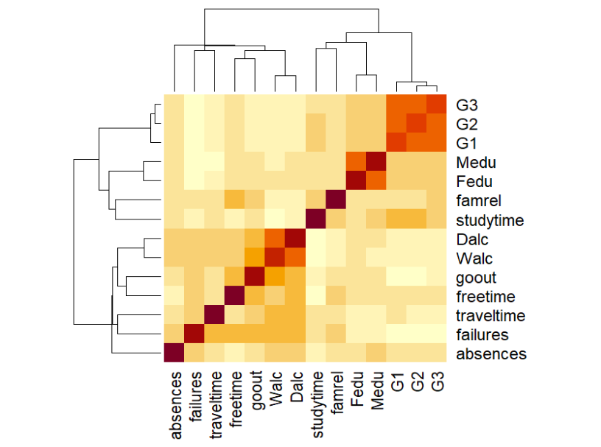
Figure 5.1: Heatmap of Correlation Matrix

The heatmap shows that G2 has a strong positive correlation with G3, indicating that second period academic performance is a key determinant of final grades. G1 also shows a moderate positive relationship with G3. Failures exhibit a negative correlation with academic performance, suggesting that students with more past failures tend to perform poorly. Lifestyle variables such as goout and freetime show weak correlations with academic performance. Parental education variables (Medu and Fedu) show a mild positive association. Overall, prior academic performance emerges as the most important factor.

5.3 Modeling with classical MLR

Two multiple linear regression models were fitted to evaluate the effect of prior academic performance:
- Model 1: Model in which G3 (final grade) as predictor and all other variables as response but, exclude G1 (First period grade) and G2 (Second period grade) variables.
- Model 2: Model in which G3 (final grade) as predictor and all other variables as response with including G1 (First period grade) and G2 (Second period grade) variables.
To evaluate the impact of including prior academic performance variables, two multiple linear regression models were fitted and compared. The model was estimated without and with including G1 (1st period grade) and G2 (2nd period grade) as dependent variables and G3 (final grade) The purpose of this comparison is to assess how the inclusion of prior grades affects the explanatory power and predictive performance of the regression model.

Table 5.3: model comparison of MLR
Measure | Model 1 (Without G1, G2) | Model 2 (With G1, G2) | Interpretation
R-squared | 0.2888 | 0.85 | Large increase → Model 2 explains much more variation
Adjusted R² | 0.1971 | 0.8296 | Model 2 remains strong even after adjustment
Residual Std. Error | 4.105 | 1.891 | Lower error in Model 2 → better prediction accuracy
F-statistic | 3.149 | 41.82 | Model 2 is much more statistically significant
p-value | 1.348 × 10⁻⁹ | < 2.2 × 10⁻¹⁶ | Both models significant, but Model 2 is stronger
Key Predictors | Absence, Failures, Goout, Romantic | G2, G1, Famrel, Absences | Prior grades dominate in Model 2
Overall Performance | Moderate | Excellent | Model 2 clearly superior

The comparison of the two regression models clearly indicates that the model including prior academic performance variables (G1 and G2) performs significantly better than the model without them. The R-squared value increases substantially from 0.2888 to 0.85, showing a major improvement in explanatory power. Additionally, the residual standard error decreases, indicating higher prediction accuracy. Therefore, it can be concluded that prior academic performance is the most important determinant of final grades, and the model including G1 and G2 is the preferred model.

5.4 Checking Assumption for regression

Before interpreting the results of the regression model, it is essential to verify whether the underlying assumptions of linear regression are satisfied. The key assumptions include linearity, normality of residuals, homoscedasticity, and absence of influential observations. These assumptions were examined using standard diagnostic plots.

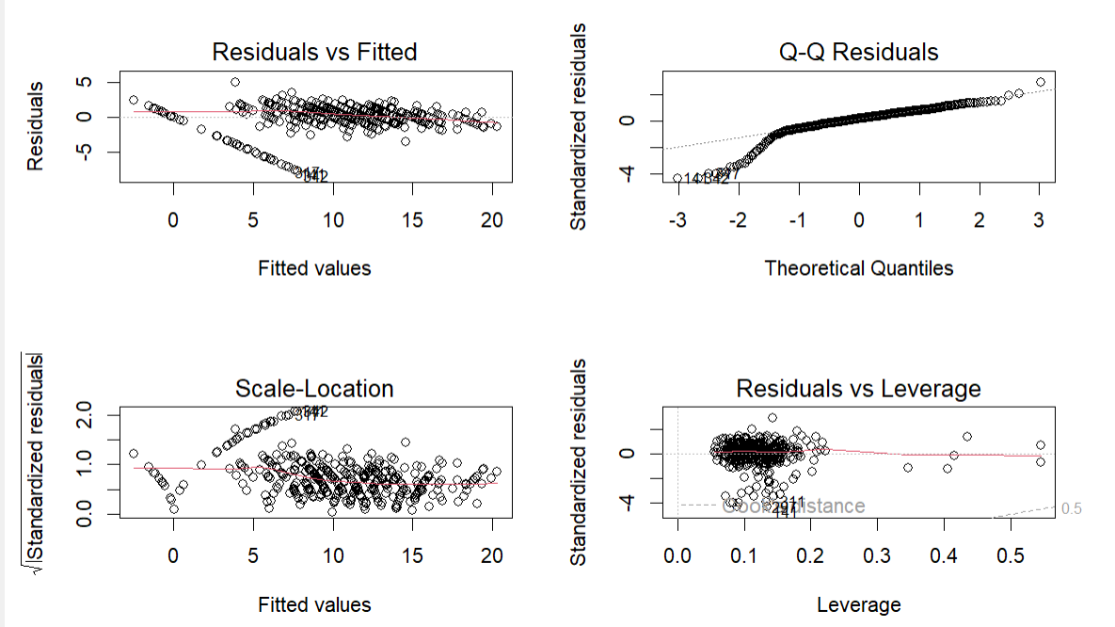
Figure 5.2 Diagnostic Plots for Classical Regression Model

In Figure 5.2 The Residuals vs Fitted plot shows that the residuals are approximately scattered around zero, indicating that the linearity assumption is reasonably satisfied, although slight patterns are observed.
The Q–Q plot indicates some deviation from normality, particularly in the tails. However, given the large sample size, this deviation is not considered severe.
The Scale–Location plot suggests slight variation in the spread of residuals, indicating minor heteroscedasticity. However, no strong funnel shape is observed.
The Residuals vs Leverage plot shows that most observations have low leverage and lie within Cook’s distance limits, indicating no highly influential observations.
Here, VIF values less than 5 indicate that multicollinearity is not a serious issue in the model. Overall, the regression assumptions are reasonably satisfied, and the model is considered appropriate for further analysis.

5.5 Modelling with Simultaneous Equation Modelling

Since the assumptions of the multiple linear regression model are reasonably satisfied, the model results are considered valid. However, regression analysis captures only a single relationship at a time and does not account for the interdependence between variables.
In this study, academic performance is measured at multiple stages (G2 and G3), which are interrelated. Therefore, to capture the simultaneous relationships between these variables, a simultaneous equation modelling approach is adopted.
The variables included in the simultaneous equation model were selected based on their theoretical relevance and statistical significance observed in the regression analysis. Variables such as study time, failures, and social activities (going out) were considered important determinants of intermediate academic performance (G2). Similarly, variables like G2, absences, romantic relationship, and gender were included in the second equation as they are expected to influence final academic performance (G3).
Other variables were excluded from the model as they were found to be statistically insignificant or did not have strong theoretical justification. Including too many variables may reduce model interpretability and lead to overfitting. Therefore, a parsimonious model with relevant predictors was preferred.
Two equations were used:
Equation 1: G2 depends on studytime, failures, and goout.
Equation 2: G3 depends on G2, absences, romantic, and sex.
Interpretation:
The table 5.4 is the overall model summary of the simultaneous equation modelling.
Table 5.4 Overall Model Summary
Statistic | Value
Total Observations | 395
System R² | 0.548
McElroy R² | 0.744

• The model explains a good amount of variation in students' academic performance.
• The relationship between second period grade and final grade is captured well by the simultaneous equation system.

Equation 1: Dependent Variable: G2 (Second Period Grade)
Table 5.5 Equation 1
Variable | Coefficient | p-value | Interpretation
Study time | 0.32 | 0.134 | Positive effect but not statistically significant
Failures | -1.664 | <0.001 | Significant negative effect
Going out | -0.394 | 0.013 | Significant negative effect

• Failures significantly reduce the second period grade.
• Going out with friends also negatively affects academic performance.
• Study time has a positive effect but is not statistically significant.
Model R² = 0.146 This means about 14.6% variation in G2 is explained by these variables.
Equation 2: Dependent Variable: G3 (Final Grade)
Table 5.6 Equation 2
Variable | Coefficient | p-value | Interpretation
G2 | 1.183 | <0.001 | Strong positive effect
Absences | 0.041 | 0.001 | Statistically significant
Romantic | -0.296 | 0.176 | Not significant
Sex | 0.152 | 0.453 | Not significant

• Second period grade (G2) strongly influences the final grade.
• Absences show a statistically significant effect.
• Romantic relationship and gender do not show significant influence in this model.
Model R² = 0.820
This means about 82% variation in final grade is explained by the variables in the model.
Table 5.7 Residual Covariance Matrix
 | eq1 | eq2
eq1 | 12.18 | -1.23
eq2 | -1.23 | 3.82

The negative covariance (-1.23) indicates a slight inverse relationship between the unexplained components of the two equations.

Table 5.8 Residual Correlation Matrix
 | eq1 | eq2
eq1 | 1 | -0.181
eq2 | -0.181 | 1

The correlation between residuals of the two equations is -0.181, indicating a weak negative relationship between the unexplained parts of the equations.

Conclusion:
The simultaneous equation analysis shows that:
• Past failures and social activities affect second period grades.
• Second period grade strongly determines the final grade.
• Romantic relationship and gender do not significantly influence final performance in this model.
Thus, the results highlight the importance of earlier academic performance in determining final academic outcomes.

Path Diagram:

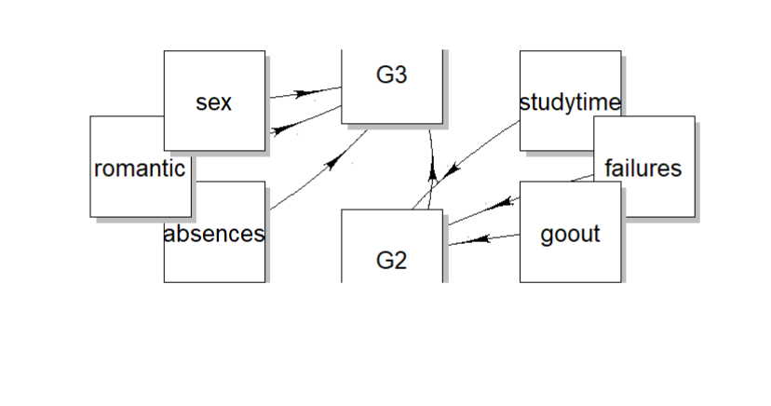
Figure 5.3 Path diagram of the Simultaneous Equation Modelling.

The path diagram represents the simultaneous equation system used to analyze student academic performance. Study time, past failures, and social activities influence the second period grade (G2). The final grade (G3) is determined by the second period grade along with absences, romantic relationship status, and gender. The diagram highlights the sequential relationship between academic periods, where earlier performance significantly influences the final outcome.

5.6 Modelling with Structural Equation Modelling

Before applying Covariance-Based Structural Equation Modelling (CB-SEM), it is necessary to verify whether the underlying assumptions of SEM are satisfied. These assumptions ensure the validity and reliability of the estimated model.

Assumptions of CB-SEM
- Multivariate Normality
Multivariate normality is a key assumption in CB-SEM. It was tested using Mardia’s test. The results show that both skewness and kurtosis are significant (p < 0.001), indicating that the data is not normally distributed. Hence, the assumption of multivariate normality is violated.
- Univariate Normality
Univariate normality of individual variables was assessed using the Anderson-Darling test. All variables show significant p-values (p < 0.001), indicating deviation from normal distribution.
- Absence of Multicollinearity
Multicollinearity among observed variables was examined. The correlation between variables was found to be within acceptable limits, indicating no serious multicollinearity problem.
- Outliers Detection
Multivariate outliers were detected using Mahalanobis distance. A few observations were identified as potential outliers. However, these were retained in the analysis as they represent valid data points and do not significantly affect the model.
- Adequate Sample Size
CB-SEM requires a sufficiently large sample size for reliable estimation. The dataset consists of 395 observations, which is adequate for SEM analysis.
Based on the above results, it is observed that the assumption of normality is violated, while other assumptions are reasonably satisfied. Therefore, CB-SEM is estimated using robust methods.

1. CB-SEM Model
To understand the complex relationships among factors influencing student academic performance, Structural Equation Modelling was applied. SEM allows simultaneous estimation of multiple relationships and incorporates both observed and latent variables.
Measurement model:
Based on the dataset, three latent constructs were defined:
- Academic Effort Indicators (observed variables): study time, absences, failures
Measurement model: Academic Effort = ~ study time + absences + failures
- Social Lifestyle Indicators: going out, free time, romantic
Measurement model: Social Lifestyle =~ going out + free time + romantic
- Family Background Indicators: Mother education, Father education, family relationship
Measurement model: Family Background =~ Mother education + Father education + family relationship
Structural model:
G2 ~ Academic Effort + Social Lifestyle + Family Background
G3 ~ G2 + AcademicEffort + SocialLifestyle
- Academic effort improves grades
- Social lifestyle may reduce academic focus
- Family background supports learning
- G2 strongly influences G3
These constructs were measured using observed indicators such as study time, absences, failures, parental education, family relationships, and social activities. The structural model then examined how these latent variables influence student grades in the second and final academic periods.
Model Fit Summary: The SEM model was estimated using lavaan with robust estimation.
Table 5.9 : Index for model fitting
Fit Index | Value of the specific index | Interpretation
Chi-square (χ²) | 88.903(df=37) P value > 0.05 | Significant (common in large samples)
CFI (Comparative Fit Index) | 0.951> 0.90 | Excellent fit
TLI (Tucker- Lewis Index) | 0.927> 0.90 | Acceptable fit
RMSEA | 0.060< 0.08 | Good fit
SRMR (Standardized Root Mean square) | 0.050< 0.08 | Good fit
The model demonstrates a good overall fit despite significant Chi-square.
Measurement Model:
Table 5.10: Standardized Factor Loadings

Latent Variable | Indicator | Loading (Std.all) | Interpretation
AcademicEffort | studytime | 0.216 | Weak
 | absences | -0.061 | Very weak
 | failures | -0.823 | Strong (negative)
SocialLifestyle | goout | 0.821 | Strong
 | freetime | 0.346 | Moderate
 | romantic | 0.023 | Very weak
FamilyBackground | Medu | 0.833 | Strong
 | Fedu | 0.748 | Strong
 | famrel | 0.003 | Very weak
- AcademicEffort is mainly represented by failures, while other indicators are weak.
- SocialLifestyle is strongly represented by goout, while romantic has negligible contribution.
- FamilyBackground is well explained by Medu and Fedu, but famrel is insignificant.
Some indicators (absences, romantic, famrel) show very low loadings and may not adequately represent their constructs.

Structural Model:
Table 5.11: Regression Results
Dependent Variable | Predictor | Std.all | p-value | Interpretation
G2 | AcademicEffort | 0.367 | 0.001 | Significant
 | SocialLifestyle | -0.126 | 0.162 | Not significant
 | FamilyBackground | 0.123 | 0.271 | Not significant
G3 | G2 | 0.886 | <0.001 | Highly significant
 | AcademicEffort | 0.055 | 0.197 | Not significant
 | SocialLifestyle | 0.028 | 0.548 | Not significant

- Academic Effort significantly influences G2.
- G2 has a very strong and significant effect on G3.
- Social Lifestyle and Family Background do not significantly affect G2 or G3.
Academic performance (G3) is primarily driven by prior performance (G2).

Covariances:
Table 5.12: Covariance between Latent Variables
Variables | Std.all | p-value | Interpretation
AcademicEffort ↔ SocialLifestyle | -0.201 | 0.269 | Not significant
AcademicEffort ↔ FamilyBackground | 0.361 | 0.119 | Not significant
SocialLifestyle ↔ FamilyBackground | 0.084 | 0.229 | Not significant

No significant relationships were observed among latent variables.
Variances:
Most observed variables show significant variances, indicating variability in data.
Some variables (e.g., failures, goout) are not significant, suggesting weak contribution.
Path diagram
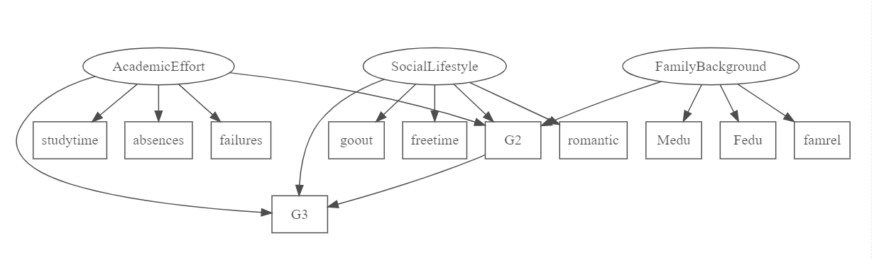

Figure 5.4 Path diagram of the CB-SEM

2. Model Modification for the CB-SEM

Based on the results of the initial SEM model estimated using lavaan, several observed variables exhibited very low factor loadings, indicating weak contribution to their respective latent constructs.
Specifically, the variables absences, romantic, and famrel showed negligible loadings and were not statistically significant. Therefore, these variables were removed to improve model fit and ensure better representation of latent constructs.
A revised SEM model was then specified using only the significant indicators.
Modified Model Specification: The modified model includes the following constructs:
- Academic Effort → studytime, failures
- Social Lifestyle → goout, freetime
- Family Background → Medu, Fedu
The structural relationships remained unchanged.
Table 5.13: Model Fit Indices
Fit Index | Value | Interpretation
Chi-square (χ²) | 21.615 p=0.062 | Good fit
CFI (Comparative Fit Index) | 0.992 | Excellent fit
TLI (Tucker- Lewis Index) | 0.982 | Excellent fit
RMSEA(Root Mean Square Error | 0.041 | Very good fit
SRMR(Standardized Root Mean square) | 0.031 | Very good fit

The modified model shows a significant improvement in fit compared to the initial model. The Chi-square value is non-significant, and all other fit indices indicate an excellent model fit.
Measurement Model (Modified)
Table 5.14: Factor Loadings
Latent Variable | Indicator | Std.all | Interpretation
Academic Effort | studytime | 0.225 | Weak
 | Failures | -0.772 | Strong
Social Lifestyle | Gout | 0.835 | Strong
 | Freetime | 0.341 | Moderate
Family Background | Medu | 0.838 | Strong
 | Fedu | 0.744 | Strong

The revised measurement model shows improved factor loadings, with most indicators contributing meaningfully to their respective constructs.

Structural Model (Modified)
Table 5.15: Path Coefficients
Dependent Variable | Predictor | Std.all | p-value | Interpretation
G2 | Academic Effort | 0.405 | 0.001 | Significant
 | Social Lifestyle | -0.109 | 0.150 | Not significant
 | Family Background | 0.098 | 0.344 | Not significant
G3 | G2 | 0.882 | <0.001 | Highly significant
 | Academic Effort | 0.060 | 0.181 | Not significant
 | Social Lifestyle | 0.028 | 0.545 | Not significant

Academic effort significantly influences G2, and G2 strongly predicts G3. Other variables do not show significant effects.
Path diagram

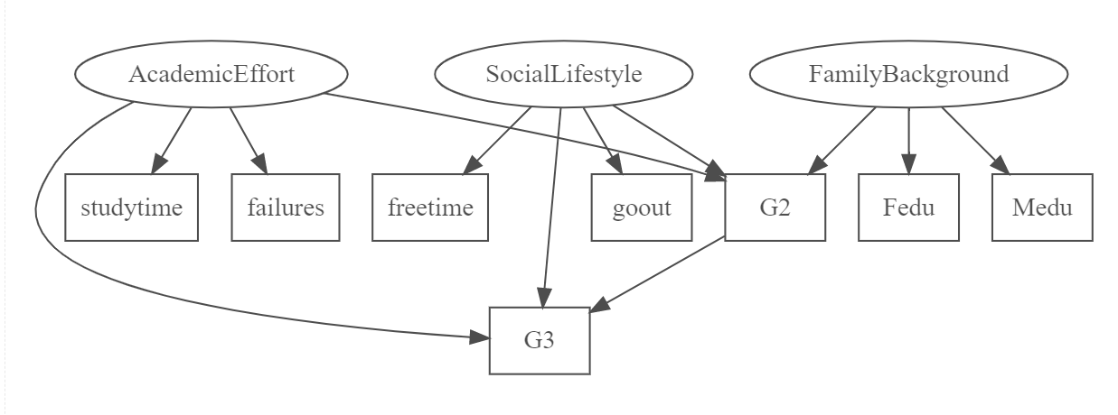
Figure 5.5 Path diagram of the CB-SEM (modified model)

Comparison of both the model original model and modified model.
Table5.16: Original vs Modified Model
Fit Index | Original Model | Modified Model
CFI (Comparative Fit Index) | 0.951 | 0.992
TLI (Tucker- Lewis Index) | 0.927 | 0.982
RMSEA(Root Mean Square Error | 0.060 | 0.041
SRMR (Standardized Root Mean square) | 0.050 | 0.031

The modified model demonstrates a clear improvement in model fit and is more parsimonious.
Conclusion:
The modified SEM model provides a better representation of the data. Academic effort plays a significant role in determining G2, while G2 strongly influences G3. The refined model is more reliable and interpretable

3. PLS SEM:

PLS-SEM was used due to non-normality of data.
The PLS-SEM model is estimated using the plspm package in R.
The model examines the effect of Academic Effort, Social Lifestyle, and Family Background on student performance (G2 and G3), with G2 acting as a mediating variable.
Model Interpretation:
Table5.17: Model Specification
Component | Value | Interpretation
Sample Size | 395 | Sufficient for PLS-SEM
Latent Variables | 5 | Academic Effort, Social Lifestyle, Family Background, G2, G3
Manifest Variables | 6 | Observed indicators used
Data Type | Standardized | All variables scaled
Bootstrapping | Yes (100 samples) | Used for significance testing
Convergence | 3 iterations | Model converged quickly

Outer Model (Measurement Model)
Table5.18: Loadings & Reliability
Construct | Indicator | Loading | Communality | Interpretation
Academic Effort | failures | 1.000 | 1.000 | Perfect loading (single indicator)
Social Lifestyle | Going out | 1.000 | 1.000 | Perfect loading
Family Background | Mother edu | 0.927 | 0.859 | Strong indicator
Family Background | Father edu | 0.871 | 0.759 | Strong indicator
G2 | G2 | 1.000 | 1.000 | Perfect
G3 | G3 | 1.000 | 1.000 | Perfect

- All loadings > 0.7 → Good reliability
- Family Background indicators are strong
- Other constructs have single indicators → automatically perfect
Discriminant Validity (Cross Loadings)
Table 5.19: Cross Loadings
Indicator | Own Construct Loading | Other Loadings | Result
Failures | 1.000 | lower values | Valid
Gout | 1.000 | lower values | Valid
Medu | 0.927 | lower values | Valid
Fedu | 0.871 | lower values | Valid
G2 | 1.000 | lower values | Valid
G3 | 1.000 | lower values | Valid
Each indicator loads highest on its own construct Discriminant validity is satisfied.

Structural Model (Inner Model):
Table 5.20: Path Coefficients
Path | Coefficient | t-value | p-value | Result
AcademicEffort → G2 | -0.301 | -6.19 | <0.001 | Significant
SocialLifestyle → G2 | -0.133 | -2.84 | 0.004 | Significant
FamilyBackground → G2 | 0.142 | 2.93 | 0.003 | Significant
AcademicEffort → G3 | -0.045 | -1.97 | 0.049 | Weak
SocialLifestyle → G3 | 0.018 | 0.80 | 0.421 | Not Significant
G2 → G3 | 0.892 | 38.60 | <0.001 | Strong

Correlation Between Latent Variables:
Table 5.21: Correlations
Variables | Correlation | Interpretation
G2 & G3 | 0.905 | Very strong positive
AcademicEffort & G2 | -0.356 | Moderate negative
AcademicEffort & G3 | -0.360 | Moderate negative
FamilyBackground & G2 | 0.214 | Weak positive
SocialLifestyle & G2 | -0.162 | Weak negative

Moodel fit :
Goodness of fit values is 0.6297 then it is a good model fit
GoF > 0.36 → Strong model
Conclusion: The PLS-SEM results confirm that the measurement model is reliable and valid. The structural model shows that G2 is the strongest predictor of G3 and acts as a mediator, while academic effort negatively and family background positively influence student performance.

5.7 Performance of Models

In this study, multiple statistical models were applied to analyze student academic performance, including Multiple Linear Regression (MLR), Simultaneous Equation Modelling (SEM system), Covariance-Based Structural Equation Modelling (CB-SEM), and Partial Least Squares Structural Equation Modelling (PLS-SEM). Each model provides different insights based on its assumptions and methodological framework. A comparison of these models is presented below to identify the most suitable approach.

Table 5.22: comparison of the model

Model | Key Features | Strengths | Limitations | Interpretation
Multiple Linear Regression (MLR) | Models’ relationship between G3 and predictors | Simple, easy to interpret | Cannot capture interdependence among variables | Shows G2 and G1 as strongest predictors; good for initial understanding
Simultaneous Equation Model | Models G2 and G3 together | Captures interrelationship between variables | More complex, requires specification | Shows G2 mediates effect of other variables on G3
CB-SEM | Theory-based structural modelling | Provides model fit indices, tests latent constructs | Requires normality (violated here) | Confirms G2 strongly influences G3; some constructs weak
PLS-SEM | Variance-based SEM | Works with non-normaldata, flexible | Less strict theoretical basis | Provides most reliable results; confirms G2 as strongest predictor

Summary of the findings:
- Multiple Linear Regression (MLR)
The MLR model provides a basic understanding of the relationship between independent variables and final grade (G3). It shows that prior academic performance (G1 and G2) has a strong and significant effect on G3. However, this model does not account for relationships among predictors or indirect effects.
- Simultaneous Equation Model
The simultaneous equation model improves upon MLR by considering the interdependence between variables. It demonstrates that G2 acts as an intermediate variable (mediator), influenced by factors such as studytime and failures, and in turn affecting G3. This highlights the sequential nature of academic performance.
- CB-SEM
CB-SEM provides a theory-driven approach by incorporating latent variables such as Academic Effort, Social Lifestyle, and Family Background. The model shows acceptable fit indices; however, the assumption of multivariate normality is violated. Despite this, the results confirm that G2 is the most important predictor of G3, while other latent constructs show weaker influence.
- PLS-SEM
PLS-SEM is more suitable for the given dataset as it does not require strict normality assumptions. The model shows strong predictive performance and confirms that G2 is the primary determinant of G3. It also captures the influence of academic effort and family background more effectively compared to other models. Therefore, PLS-SEM provides the most reliable and robust results in this study.

Conclusion of Comparison:
Based on the comparative analysis, it is observed that while Multiple Linear Regression provides a simple and interpretable model, it fails to capture complex relationships among variables. The simultaneous equation model improves the analysis by incorporating interdependencies. CB-SEM offers a structured theoretical framework but is limited by the violation of normality assumptions.
Among all models, PLS-SEM is found to be the most appropriate for this study due to its flexibility, ability to handle non-normal data, and effectiveness in modelling complex relationships. Hence, PLS-SEM is considered the best model for analyzing student academic performance in this study.

5.8 PLS-SEM Prediction Analysis

PLS-SEM is widely used for both explanatory and predictive modelling. In addition to analyzing the relationships between variables, it is important to evaluate how accurately the model can predict new observations. Therefore, prediction analysis is carried out to assess the model’s predictive power for the dependent variable (G3).
- Out-of-Sample Prediction (Train–Test)
- Cross-Validated Prediction (PLSpredict)
1. Out-of-Sample Prediction (Train–Test):
The objective of this analysis is to evaluate the out-of-sample predictive performance of the PLS-SEM model using a train–test split approach.
The dataset was divided into training (70%) and testing (30%) subsets. The PLS-SEM model was estimated using the training data. Latent variable scores were obtained and used to predict the dependent variable (G3) on the test dataset. Model performance was evaluated using RMSE, MAE, and R².
5.23 Table Prediction Results Table

Measure | Value
RMSE | 10.76
MAE | 9.93
R² | 0.73

Interpretation
The results of the PLS-SEM prediction analysis indicate that the model has good predictive capability. The R-squared value of 0.73 suggests that approximately 73.3% of the variation in the dependent variable (G3) is explained by the model, indicating strong explanatory power.
The RMSE value of 10.76 and MAE value of 9.93 indicate the average prediction error of the model. While the errors are moderate, they are acceptable given the complexity of the data and the presence of latent constructs.
Overall, the PLS-SEM model demonstrates satisfactory predictive performance and is suitable for modelling student performance data.
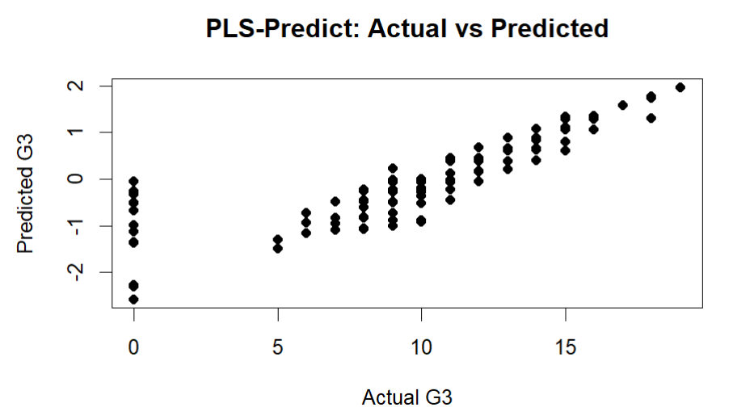
Fig 5.6 PLS –SEM Actual values and Fitted values

The scatter plot of actual versus predicted values shows that most points lie close to the diagonal line, indicating good predictive accuracy. This suggests that the PLS-SEM model performs well in predicting unseen data.
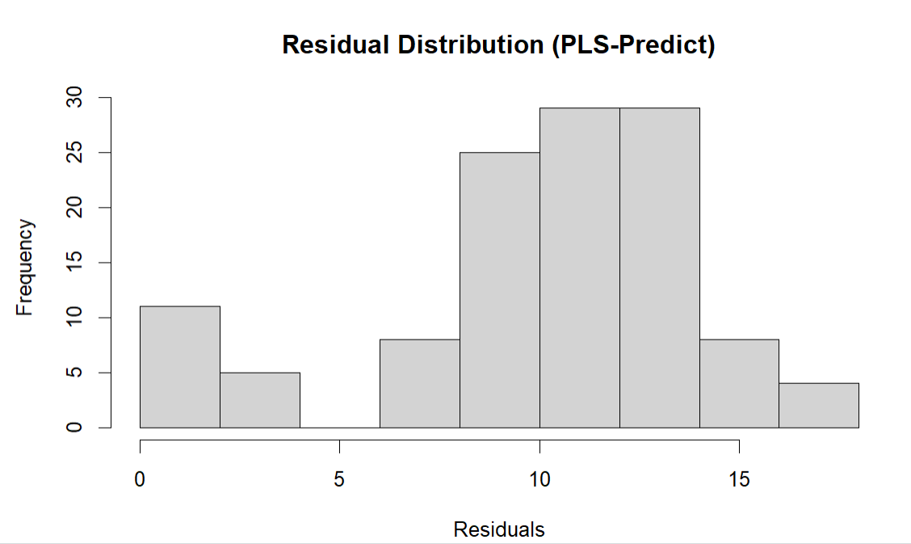
Fig 5.7 Residual distribution of PlS-SEM (prediction)
The histogram of residuals represents the distribution of prediction errors obtained from the PLS-SEM model. It can be observed that the residuals are reasonably distributed, although not perfectly symmetric. Most of the residual values are concentrated within a moderate range, indicating that the model does not produce extremely large prediction errors.
However, the distribution appears slightly skewed and does not strictly follow a normal distribution. This suggests that while the model performs adequately, there is some variation in prediction accuracy across observations.
The residuals are moderately distributed and do not show extreme deviations, indicating acceptable model performance. However, slight skewness suggests that prediction errors are not perfectly normal.
2. Cross-Validated Prediction (PLSpredict):
To evaluate the robustness and generalizability of the PLS-SEM model, a 10-fold cross-validation approach was employed. In this method, the dataset was divided into ten equal subsets, where in each iteration, nine subsets were used for model training and one subset was used for testing. This process was repeated ten times, ensuring that each observation was used for both training and validation.
The predictive performance of the model was assessed using Root Mean Square Error (RMSE), Mean Absolute Error (MAE), and Coefficient of Determination (R²). The average values of these metrics across all folds are presented in Table below.
Table 5.24 Cross-Validated Prediction values
Measure | Value
RMSE | 11.08
MAE | 10.42
R² | 0.83
The cross-validation results indicate that the PLS-SEM model demonstrates stable and reliable predictive performance. The average RMSE (11.08) and MAE (10.42) values suggest moderate prediction error, which is acceptable given the complexity of the dataset.
The R² value of 0.83 indicates strong explanatory and predictive capability across different subsets of data. Compared to the train–test results, the slightly higher error values in cross-validation reflect a more robust and realistic assessment of model performance.
Overall, the consistency of results across folds suggests that the model generalizes well and is not overly dependent on a specific data split.
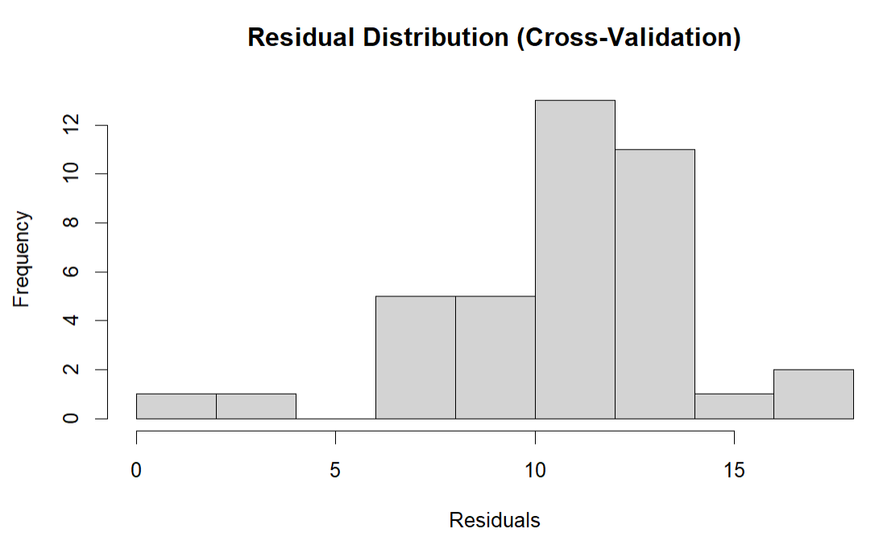
Fig 5.8 Residual distribution of Cross-Validated Prediction
The residual distribution obtained from cross-validation indicates that prediction errors are moderately concentrated within a specific range, with most residuals lying between 8 and 14. The distribution shows slight positive skewness, suggesting that the model tends to slightly under-predict the actual values.
Although the residuals are not perfectly symmetric around zero, there are no extreme deviations or outliers, indicating stable predictive performance across different folds. The moderate spread of residuals suggests that the model produces consistent predictions with acceptable error levels.
Overall, the residual analysis confirms that the PLS-SEM model demonstrates reliable and stable predictive performance under cross-validation.
Table 5.25 Comparison of Prediction Methods
Measure | Train–Test | Cross-Validation
RMSE | 10.76 | 11.08
MAE | 9.93 | 10.42
R² | 0.73 | 0.83
A comparison between the train–test split method and cross-validation approach was conducted to evaluate the consistency and reliability of the PLS-SEM model.
The results indicate that the RMSE and MAE values obtained from cross-validation are slightly higher than those from the train–test method. This increase in prediction error is expected, as cross-validation provides a more rigorous and realistic assessment by evaluating the model across multiple data subsets rather than a single split.
On the other hand, the R² value is higher in the cross-validation approach, suggesting that the model maintains strong explanatory power across different folds and is not dependent on a particular partition of the data.
Overall, while the train–test method provides a quick estimate of model performance, cross-validation offers a more robust and reliable evaluation. Therefore, the cross-validation results are considered more representative of the true predictive capability of the PLS-SEM model.

5.9 Machine Learning Prediction Performance

Machine learning models were applied to predict the final grade (G3) using the available dataset. All predictor variables were included in the analysis to allow a data-driven evaluation of model performance.
The dataset was divided into training (70%) and testing (30%) sets. The models were trained using the training data, and predictions were generated on the testing data to evaluate their performance.
1. Decision Tree Model
The Decision Tree model is used to predict the final academic performance of students (G3) based on several explanatory variables such as previous grades, attendance, and other academic factors. The tree structure provides a clear and interpretable set of decision rules that explain how student performance is determined.
At the root node, the model considers all 276 observations (100%), with an average predicted value of 11. This represents the overall mean performance of students in the dataset.
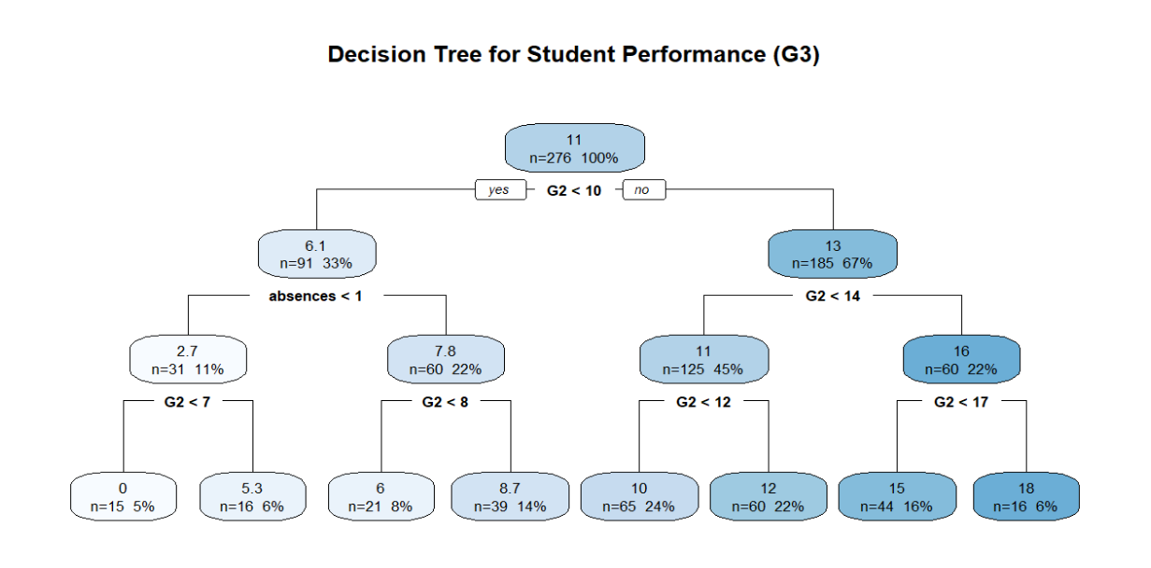
Fig :5.9 Decision Tree for student performance
The decision tree model identifies G2 (second period grade) as the most important predictor of final grade (G3). The first split occurs at G2 < 10, clearly separating students into low and high academic performance groups.
Students with G2 < 10 generally show lower final performance, with further reduction in scores observed among those having higher absences. Their predicted G3 values range from very low (around 0–5) to moderate (up to 8.7), indicating that poor prior performance combined with low attendance negatively affects outcomes.
In contrast, students with G2 ≥ 10 show significantly better performance. As G2 increases (especially ≥ 14), the predicted final grades rise steadily, reaching values between 15 and 18. This confirms a strong positive relationship between prior academic performance and final results.
Overall, the model highlights that previous academic performance (G2) is the strongest determinant of final grade, while attendance (absences) further influences outcomes, particularly for weaker students.
2. Random Forest Model
To evaluate the performance and stability of the Random Forest model, the Out-of-Bag (OOB) error is plotted against the number of trees. The OOB error provides an internal estimate of prediction error without the need for a separate validation set. It helps in assessing how well the model generalizes as more trees are added to the forest.
The following graph shows how the OOB error changes with increasing number of trees in the Random Forest model.
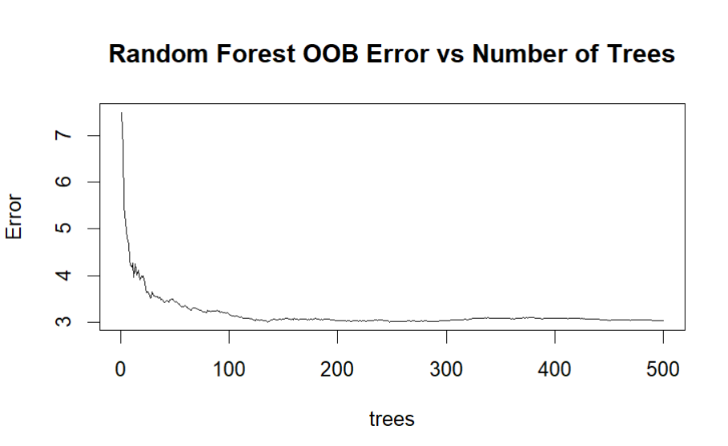
Fig 5.10 Random forest OOb error vs number of trees
The graph shows the relationship between the Out-of-Bag (OOB) error and the number of trees in the Random Forest model.
At the beginning, when the number of trees is small, the OOB error is quite high (around 7–7.5). This indicates that the model is unstable and has higher prediction error when only a few trees are used.
As the number of trees increases (from 0 to around 50), the OOB error decreases sharply. This shows that adding more trees significantly improves the model performance by reducing variance and improving stability.
After approximately 100 trees, the OOB error starts to stabilize around 3 to 3.2. Beyond this point, even when the number of trees increases up to 500, there is only a very slight reduction in error. This indicates that the model has reached a convergence point, where adding more trees does not significantly improve accuracy.
- High initial error with few trees indicates unstable predictions.
- Rapid decrease in error shows strong learning improvement with more trees.
- Stabilization after ~100 trees suggests optimal model performance is achieved early.
- Final OOB error (~3) represents the expected generalization error of the model.
The Random Forest model becomes stable after a sufficient number of trees (around 100–150). Increasing trees beyond this point does not significantly improve performance. Therefore, the model is well-tuned, and the OOB error indicates good predictive ability with low generalization error.
3. XGBoost Model
To evaluate the relative contribution of each predictor variable in the XGBoost model, feature importance analysis was conducted. This method highlights which variables have the greatest influence on the model’s decision-making process. The following chart presents the ranked importance scores of all features considered, allowing us to identify the most impactful predictors.
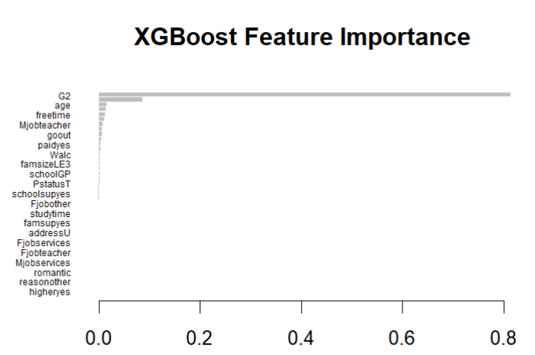
Fig 5.11 XGBoost feature important
Interpretation of graph
- G2: This feature overwhelmingly dominates the model, with an importance score close to 0.8. It is by far the strongest predictor, meaning the model relies heavily on this variable when making predictions.
- Age and freetime: These appear as secondary contributors, though their importance is much lower compared to G2. They provide additional nuance but are not decisive on their own.
- Mjobteacher, goout, and paidyes: These mid-level features suggest that parental occupation, social habits, and financial support have moderate influence.
- Walc and famsizeLE3: These variables contribute modestly, indicating lifestyle and family structure factors play a smaller role.
The remaining features (such as schoolGP, studytime, and romantic) have relatively low importance scores, suggesting they add marginal predictive value compared to the dominant G2 feature.
4. Support Vector Regression
To evaluate the performance of the Support Vector Regression (SVR) model, an Actual vs Predicted plot is used. This graph helps in visually comparing the predicted values of the target variable (G3) with the actual observed values. A perfect model would have all points lying exactly on the diagonal line (y = x).
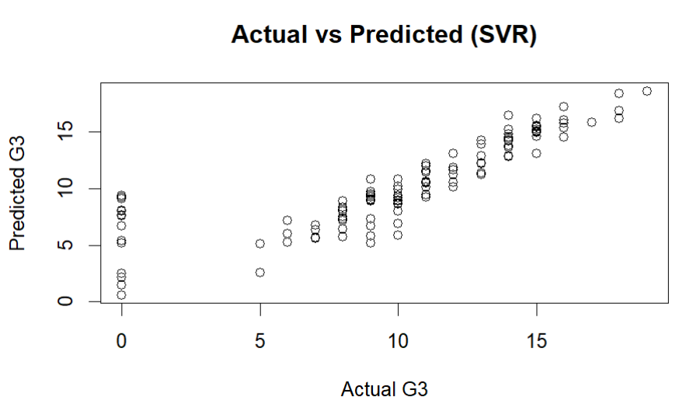
Fig 5.12 Auctual vs Fitted of SVR
The Actual vs Predicted plot for the SVR model shows that most data points are closely aligned along the diagonal reference line (y = x). This indicates that the predicted values are very close to the actual values of student performance (G3).
The closer the points are to the diagonal line, the lower the prediction error. In this case, the small deviation of some points from the line represents minor prediction errors, which are expected in real-world data.
Hence, the SVR model demonstrates strong predictive accuracy and effectively captures the relationship between predictor variables and student academic performance.
The following machine learning models were implemented: Decision Tree, Random Forest, XGBoost, and Support Vector Regression (SVR).
Table 5.25 Machine learning model value
Model | RMSE ↓ | MAE ↓ | R² ↑
Decision Tree | 2.019 | 1.303 | 0.831
Random Forest | 2.310 | 1.475 | 0.794
XGBoost | 2.087 | 1.339 | 0.822
SVR | 2.623 | 1.597 | 0.723

The comparison of machine learning models shows that the Decision Tree model provides the best predictive performance among the models considered. It has the lowest RMSE (2.019) and MAE (1.303), along with the highest R² value (0.831), indicating better accuracy in predicting the final grade (G3).
The XGBoost model also shows strong performance, with RMSE (2.087) and R² (0.822) values close to the Decision Tree, indicating its effectiveness in capturing the underlying patterns in the data.
The Random Forest model shows comparatively lower performance, with higher RMSE and MAE values and a lower R² (0.794). This suggests that, in this dataset, the ensemble approach does not provide additional improvement over simpler models.
Overall, the results indicate that the Decision Tree model performs best for predicting student performance, followed closely by XGBoost.
Comparison with PLS-SEM Prediction
Table 5.26 comparision between pls-sem and ml model
Model | RMSE ↓ | MAE ↓ | R² ↑
PLS-SEM (Cross-Validation) | 11.08 | 10.42 | 0.83
Decision Tree | 2.019 | 1.303 | 0.831

The comparison between the cross-validated PLS-SEM model and the Decision Tree model shows a clear difference in predictive performance. The PLS-SEM model achieved an R² value of 0.83, which is almost equal to the Decision Tree model (R² = 0.831), indicating similar explanatory power.
However, in terms of prediction error, the Decision Tree model performs significantly better, with much lower RMSE (2.019) and MAE (1.303) compared to PLS-SEM (RMSE = 11.08, MAE = 10.42). This indicates that the Decision Tree model provides more accurate predictions.
The predictive performance of machine learning models was compared with the results obtained from PLS-SEM. The PLS-SEM approach provided a structured prediction framework based on relationships among variables, while machine learning models focused purely on predictive accuracy.
The results indicate that machine learning models, particularly the Decision Tree and XGBoost, achieve strong predictive performance in estimating the final grade (G3). These models effectively capture patterns in the data without relying on predefined structural relationships.
In comparison, PLS-SEM provides valuable insights into the relationships between variables and supports interpretation, whereas machine learning models offer improved flexibility in prediction. Thus, both approaches complement each other, with SEM contributing to understanding and machine learning enhancing predictive performance.
The machine learning models identify G2 as the most important predictor of the final grade (G3) based on predictive performance. However, machine learning does not explain the underlying relationships among variables.
The SEM analysis conducted earlier provides this explanation by showing how other factors influence G2, which in turn affects G3. Thus, machine learning highlights important predictors, while SEM explains the relationships behind them.

Chapter 6: Conclusion

6.1 Overall Conclusion

This study was conducted to analyze the factors influencing student academic performance using a comprehensive statistical approach. Various techniques, including correlation analysis, Multiple Linear Regression, Simultaneous Equation Modelling, Covariance-Based Structural Equation Modelling (CB-SEM), and Partial Least Squares Structural Equation Modelling (PLS-SEM), were applied to gain deeper insights into the relationships among variables.
The correlation analysis provided initial understanding of the relationships among variables and indicated that prior academic performance, particularly the second period grade (G2), has a strong positive association with final grade (G3). This suggests that students’ performance in earlier stages plays a crucial role in determining their final outcomes.
The Multiple Linear Regression model further confirmed that G2 (second period grade) G1 (First period grade) are the most significant predictors of G3(final grade). The inclusion of prior academic performance variables significantly improved the explanatory power of the model, indicating that past performance is a strong determinant of future achievement.
The simultaneous equation modelling approach extended the analysis by capturing the interrelationship between variables. It demonstrated that second period grade acts as an intermediate (mediating) variable influenced by factors such as study time, failures, and going out, and in turn strongly affects final grade. This highlights the sequential nature of academic performance, where earlier outcomes influence later results.
The Structural Equation Modelling approach provided a more comprehensive framework by incorporating latent constructs. In this study, three latent variables were considered:
- Academic Effort (studytime, failures)
- Social Lifestyle (goout, freetime)
- Family Background (Medu, Fedu)
The CB-SEM results indicated that Academic Effort has a significant influence on G2(second period grade), while G2 (second period grade) has a very strong effect on G3(final grade). However, the assumption of multivariate normality was violated, which limits the reliability of CB-SEM results.
To address this limitation, PLS-SEM was applied as it does not require strict normality assumptions. The PLS-SEM results confirmed that G2(second period grade) is the strongest predictor of G3(final grade) and acts as a mediating variable between other factors and final performance. Academic Effort showed a significant effect on G2, while Family Background had a moderate positive influence. Social Lifestyle showed relatively weaker and less consistent effects.
The prediction capability of the model was evaluated using PLS-SEM, which demonstrated satisfactory predictive performance. This approach provided a structured framework for prediction based on the relationships identified in SEM. Further, machine learning models were applied to enhance prediction accuracy. The results showed that Decision Tree and XGBoost models achieved strong predictive performance, with Decision Tree providing the best results among the models considered. The machine learning analysis also identified G2 as the most important predictor of the final grade. While machine learning models focus on prediction accuracy, they do not explain the relationships among variables. In contrast, SEM explains how different factors influence G2 and ultimately G3. Thus, the findings from machine learning are consistent with and support the results obtained from SEM.
Overall, the study demonstrates that prior academic performance is the most significant determinant of final grade. The combined use of statistical models and machine learning provides a comprehensive approach, where SEM contributes to understanding relationships and machine learning enhances predictive performance.
This integrated approach improves both interpretation and prediction, making it useful for analyzing and forecasting student performance.
Overall, the results across all models consistently indicate that prior academic performance is the most critical factor influencing final academic outcomes. Among the models applied, PLS-SEM is found to be the most suitable approach for this study due to its flexibility, robustness, and ability to handle complex relationships and non-normal data.

6.2 Key Findings of the Study

The major findings of the study are summarized as follows:
- Second period grade (G2) is the most significant predictor of final grade (G3).
- First period grade (G1) also shows a positive influence on final performance.
- Past failures have a negative impact on academic performance.
- Academic Effort (studytime, failures) plays an important role in influencing intermediate performance (G2).
- Family Background (Medu, Fedu) shows a moderate positive association with academic outcomes.
- Social Lifestyle (goout, freetime) has a relatively weaker influence on academic performance.
- G2 acts as a mediating variable between other factors and final grade (G3).
- PLS-SEM provides the most reliable and robust results among all models used.

6.3 Practical Implications

The findings of this study have important implications for educational institutions, teachers, and policymakers. Since prior academic performance strongly influences final outcomes, early identification of students with poor performance is essential. Institutions should focus on improving student performance at earlier stages by providing academic support and guidance.
Reducing the number of student failures and encouraging consistent study habits can significantly enhance academic outcomes. Monitoring student progress regularly can help in identifying at-risk students and implementing timely interventions.
Although social lifestyle factors such as going out and free time have some influence, their impact is relatively limited compared to academic factors. Therefore, emphasis should be placed on improving academic engagement and learning strategies.

6.4 Limitations and Future Scope

In addition, certain latent variables in the SEM analysis were represented using a limited number of observed indicators, which may affect the precision of measurement.
Future research can be extended by including larger and more diverse datasets, incorporating additional variables such as psychological, behavioral, and environmental factors, and applying advanced machine learning techniques for better prediction. Further studies may also explore hybrid approaches combining statistical modelling and machine learning methods.

References

- Cruddas, S. (2013). An introduction to structural equation modelling for emergency services and disaster research. International Journal of Emergency Services, 2(2), 131-140.
- Rigdon, E. E., Sarstedt, M., & Ringle, C. M. (2017). On comparing results from CB-SEM and PLS-SEM: Five perspectives and five recommendations. Marketing: ZFP–Journal of Research and Management, 39(3), 4-16.
- Greene, W. (2012). H.(2012): Econometric analysis. Journal of Boston: Pearson Education, 803-806.
- Rafailzadeh, B., & Kmenta, J. (1997). Solutions manual to elements of econometrics. University of Michigan Press.
- Wold, H. (1982). Systems under Indirect Observation. Systems under Indirect Observation, 2, 1-54.
- Dash, G., & Paul, J. (2021). CB-SEM vs PLS-SEM methods for research in social sciences and technology forecasting. Technological forecasting and social change, 173, 121092.
- Pérez-Sánchez, B., Perea, C., Ballester, G. D., & López-Espín, J. J. (2024). Estimation of simultaneous equation models by backpropagation method using stochastic gradient descent. PeerJ Computer Science, 10, e2352.
- Pérez-Sánchez, B., Perea, C., Gonzalez, M., & López-Espín, J. J. (2025). Evaluation of Estimation Methods for Simultaneous Equations Models Across Varying Levels of Data Variability. Data Science and Engineering, 1-10.
- McDonald, R. P., & Ho, M. H. R. (2002). Principles and practice in reporting structural equation analyses. Psychological methods, 7(1), 64.

